**Creating A Responsive Mobile First Web Page**

**Table of Contents**

Introduction 3

Code editor and libraries 3

Prerequisite knowledge 3

Live Feedback Site 3

Tutorial Style 3

Different technical approaches 4

Part 1: Set up your site and project files 5

Set up your project files 5

Define a local site folder 5

Warning, your site might not work on the Web Server 6

Part 2: Creating the page structure with a fluid grid layout 7

Evaluate the task ahead 7

Examine the comp 7

What to do if things go wrong 8

Create a fluid grid page with Bootstrap 13

Create the header 16

Convert the navigation menu to a 3-bar icon 20

Create the Footer 23

Part 3 Insert the laboratory 1 contents 27

Insert the image content 27

Part 4 Create the CSS styling rules 33

Responsive web design – CSS3 media queries 33

Create the CSS rules for the mobile main contents 34

Install and declare fonts 35

Continue to build your custom.css file 38

Get used to using Chrome Developer Tools to examine your site 40

Create the CSS rules for the mobile header logo and navigation menu 43

Style the logo 43

Style the navbar 45

Style the navigation menu 46

Style the navigation dropdown menu 49

Create the CSS rules for the footer 51

Style the footer and its contents 51

Create the CSS rules for the other screen break points 54

Tidy up your CSS 58

Part 5 Publish your website — Lab 1 60

Part 6: Set up Git and GitHub with Visual Studio Code 61

Appendices 62

Appendix A — Getting Started 62

Set up your coding environment 62

Required Libraries 62

Integrating with GitHub 62

Prerequisite knowledge 62

Live Feedback Site 62

Appendix B — Some Technical Details 64

Different technical approaches 64

Appendix C — Setting up your project files 65

Local and remote files 65

Keeping track of your sites 66

Remote update for your site 66

Appendix D — Best practices for naming files and folders in a website 68

Appendix E — Rationale for fluid grid 68

Appendix F — Setting up your Bootstrap template 69

Appendix G — Create a fluid grid page with Bootstrap 70

Appendix H — Convert the navigation menu to a 3-bar icon 71

Appendix I — Inserting Image Content 72

Appendix J — CSS media queries 74

Appendix K — Working from home 75

Appendix L — Using Git and GitHub for to manage your code 75

# Introduction

Welcome to the Part 1 of this tutorial on creating a responsive mobile first web page. You may recall on the Canvas page where you downloaded this tutorial from that we suggested two approaches to acquiring the skills and knowledge needed to complete this tutorial:

1. You could find a video tutorial online, e.g. from YouTube, and there are plenty available, and follow that to achieve the same or similar results. Here is one, for example:
   * <https://www.youtube.com/watch?v=9cKsq14Kfsw>
2. Alternatively, follow this tutorial in detail, where you can follow the instructions carefully and read the embedded learning materials as you proceed
3. Or, follow the instructions and catch up on the learning materials later.

Whichever approach you use, there is an optional tutorial quiz (go back to Canvas) that you can complete to solidify your knowledge.

## Code editor and libraries

If you do not already have a preferred coding environment, you will need to set one up. We recommend using [Visual Studio Code](https://code.visualstudio.com/). Further, all tutorials will exploit the [Bootstrap](http://getbootstrap.com/) front-end framework extensively. Also, this tutorial requires no previous knowledge of a full web development stack — you will **learn by doing** in the lab (or at home) using the provided Canvas based learning materials. For a longer discussion on setting up your coding environment, etc. **See the Appendix A for more details.**

## Prerequisite knowledge

This tutorial requires no previous knowledge of a full web development stack — you will learn by doing in the lab (or at home) using the Canvas learning materials. For a longer discussion on prerequisites, etc. **See the Appendix A for more details.**

## Live Feedback Site

This laboratory tutorial gives you, in advance, a completed version of the end result located at the **Live Feedback Site** to enable you to compare your work with an end result if you get stuck. For a longer discussion, etc. **See the Appendix A for more details.**

## Tutorial Style

This tutorial is developed from scratch, as we develop the code, we have written the tutorial in parallel. This produces more of a narrative style tutorial rather than a simple set of instructions; so, to reduce the overall length will try, where we can, to:

* Move some of the ‘learning material’ detail (as opposed to instructions) to the Appendix and provide, where appropriate Canvas quizzes to test your knowledge and understanding of key learning materials
* Provide links, e.g. in the document, to alternative third party (usually YouTube) videos that outline the same or similar key concepts.
* Provide some of our own video clips on key concepts where suitable third-party videos are not available.

The module convenors will complete and update all the lab tutorials each year again to test they still work, particularly after library updates. A particular consequence of this is that when we get coding, we sometimes change the CSS or some other code aspect, and then have to backtrack to update the tutorial text. This can lead to the odd mistake or anomaly in the tutorial text. However, there is no substitute for turning up to labs where you will find the module tutors who can correct any such anomalies, and we deeply appreciate your feedback to make the tutorials better.

## Different technical approaches

There are many different ways we could use to develop a simple responsive and mobile first web 3D application (3D App). However, we have to choose an approach, as such we are choosing to develop mostly from scratch exploiting a small number of key libraries such as Bootstrap, and a using responsive and mobile first approach, rather than hybrid or native approaches. **See Appendix B for more details.**

# Part 1: Set up your site and project files

This particular Part 1 of the tutorial shows you how to set up the project files for your Mobile Web 3D Applications site.

## Set up your project files

So, let’s get started, a web *site* generally consists of two parts:

1. A collection of files on a local computer (the local site). For example, this could be your site files on your own laptop, or your Home Share drive on the Lab machines
2. And, a location on a remote web server where you upload files when you're ready to make them publicly available (the remote site). The remote server could be provided by your ISP (Internet Service Provider), **but in the case of this module, we will be using the University Web Server.**

**Read Appendix C for more details of setting up your project files.**

## Define a local site folder

Ok, let’s actually set up your site folder:

* *pathvariable*/3dapp/lab1/

Here, my *pathvariable* happens to point to a location on Dropbox, see Figure 1. You on the other hand will have a simpler path to your Lab 1 structure, for example:

* Home Share/3dapp/lab1

Alternatively, you may be using your laptop, or Dropbox, or a portable drive.

You can see here that to organize your work for the other labs in this module you only need to add lab2, lab3 and so on. We anticipate, as your results from a previous lab are completed that, by and large, you will build on these in the following week’s lab requiring a copy of the previous lab and then to move forward by modifying it. Further, in Part 6 of this lab 1, **we will store our work in a GitHub repository**.

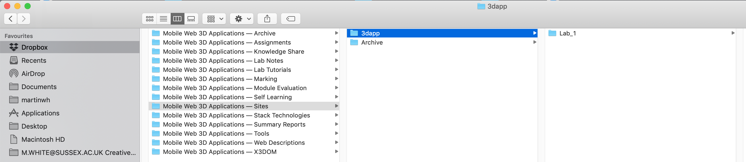

Figure 1: The initial proposed site folder structure

You will need to download from the Canvas module site the resources for this lab and insert them into the Lab 1 folder. Organise your images and text into an asset folder as indicated in Figure 2.

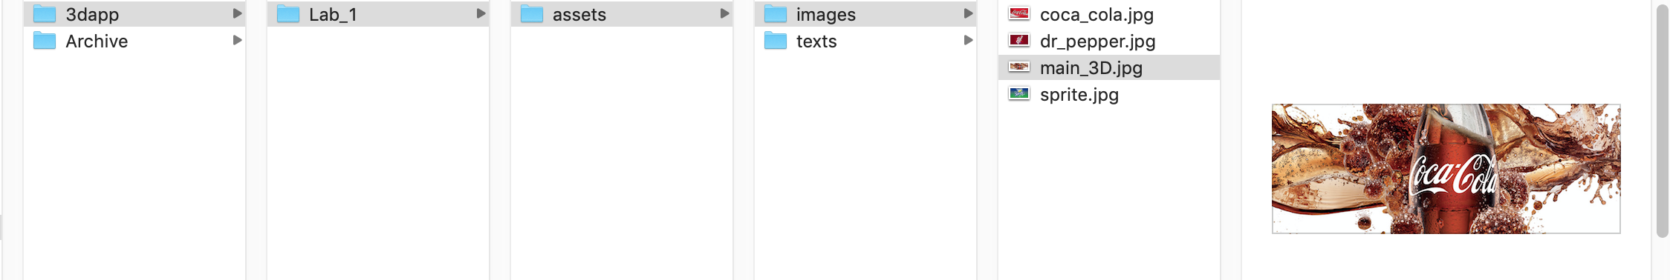

Figure 2*:* Adding some assets to the Lab 1 site structure

You've now defined a local site folder for your **Mobile** **Web 3D Applications** (3D App) Lab 1 site. This is where you will keep your working copies of your 3D App pages on your local computer (e.g. on the Home Share/3dapp/lab1 or your Laptop, and in my case I am using Dropbox).

Later, as discussed above and in detail in Appendix C, if you want to publish your pages and make them publicly available, you'll need to define a **Remote Folder** — a place on a remote computer, running a web server that holds published copies of your local files. You'll see how to do this towards the back end of this tutorial if you are actually working remotely, but it’s really easy if you are using Home Share/3dapp/lab1 for your development work, you only need to copy the site to your /public_html/ root for your assignment, e.g. /public_html/3dapp/assignment — note, we will specify the actual path for your assignment in the assignment specification.

If you are working form home though, say on a Laptop, you will need to use a SFTP client or Webdrive (search how to setup Webdrive on the ITS help pages) to upload to the ITS Web Server, your remote site.

### Warning, your site might not work on the Web Server

You should take care when naming files and folders on your site when developing on a PC which is case insensitive and porting your files to a remote web server, which is likely to be Unix based and case sensitive. **See Appendix D for more details.**

# Part 2: Creating the page structure with a fluid grid layout

The second part of this tutorial focuses on creating the fluid grid layout for your responsive mobile first web page, which is a core component of your 3D App (i.e. a web application with interactive 3D content). This section explains how to create a CSS-based fluid grid page layout (a pre-requisite for your 3D App). A fluid grid page layout determines how your page will appear in a desktop, tablet or smartphone browser showing, for example, the placement of menus, images, and other kinds of content utilizing image scaling, font resizing and CSS3 media queries.

Appendix E discusses how the rationale for creating a page structure with a fluid grid layout in more detail, don’t forget to read that information.

For this tutorial, our fluid grid layout will exploit [Bootstrap](http://getbootstrap.com/), which is, and I quote “the most popular HTML, CSS and JS framework for developing responsive, mobile first projects on the web”, or so they say!

So, you need to be careful about which versions of Bootstrap you use. You may come across code snippets that you want to adapt that only work with previous versions of Bootstrap. Indeed, in 2017 I wanted to move to Bootstrap v4.0, but it wasn’t stable enough. Instead, I had to wait a year migrated to use Bootstrap v4.0 in 2018 — **you should use the latest stable version of Bootstrap and can certainly use the previous year’s version shown on the Live Feedback Site**.

Now, it is highly likely that you will hunt around the Internet for open source code snippets with which to build your larger applications, just remember to cite them.

## Evaluate the task ahead

The first steps to creating a website usually begin on a piece of paper or in a graphics-editing application such as Adobe Photoshop. Graphic designers usually sketch out a piece of ‘comprehensive artwork’ (also known as a comp) for the website to show it to the client and make sure that the initial ideas for the site meet with their client's approval.

## Examine the comp

A comp consists of any number of page elements that the client has requested for a website. For example, the client might say, "I want to have a logo at the top of the page, a navigation that links to these other pages, a section for an online store, and a place where I can insert video clips." Based on that discussion, the designer begins planning the layout of the site and creates sketches of sample pages that fulfil the client's requirements. You are given just such a list of requirements for your 3D App assignment — refer to the assignment section on Canvas.

However, although this isn’t a web site development module, we are going to exploit a full web stack to build our 3D App. Figure 3 shows an example comp of the required Lab 1 page layout. In this particular case, the comp could simply have been constructed in Photoshop, or it could have been sketched with paper and coloured pens — I actually just took a screen shot from a previous year’s Bootstrap results for this lab to simulate a Photoshop comp.

We can see from the comp that the graphic designer has provided you with a design that includes a number of content areas. These content areas include a top banner, with logo and navigation, a main 3D viewing area, with a Coke image as a backdrop, that will display your 3D models. Beneath the main 3D area are three columns, each with an image at the top — the image can act as a button link to a new page or to load the corresponding 3D model, and the text area below. At this stage, the comp’s contents may be undecided; you now need to layout this design in HTML5 and style it in CSS3.

## What to do if things go wrong

When learning new techniques, or working with unfamiliar software, it's easy to make mistakes.

The most common causes of mistakes are accidentally skipping a step in the instructions, or miss-spelling an ID or CSS property. **If your page doesn't look the way you expect, don’t ignore it and plough on, you must retrace your steps to make sure you did everything as instructed.** The lab tutor does not have a magical wand to fix your code, well actually they do, it’s called, ‘here’s one I created earlier, located on the **Live Feedback Site**. You can look at the results there as a last resort to bug find, but although the latest this year version might not go live until a week or two after the lab session, there is always last year’s version available.

So, generally, you will find the all lab results in the **Live Feedback Site** so you can compare and contrast your results.

But, sometimes, the best idea is to start again from scratch. It can be frustrating, but you can learn a lot from your mistakes. Of course, if you do get stuck, call for help, **the course convenor, lab tutor, or lab assistant will be there in the lab every week.**

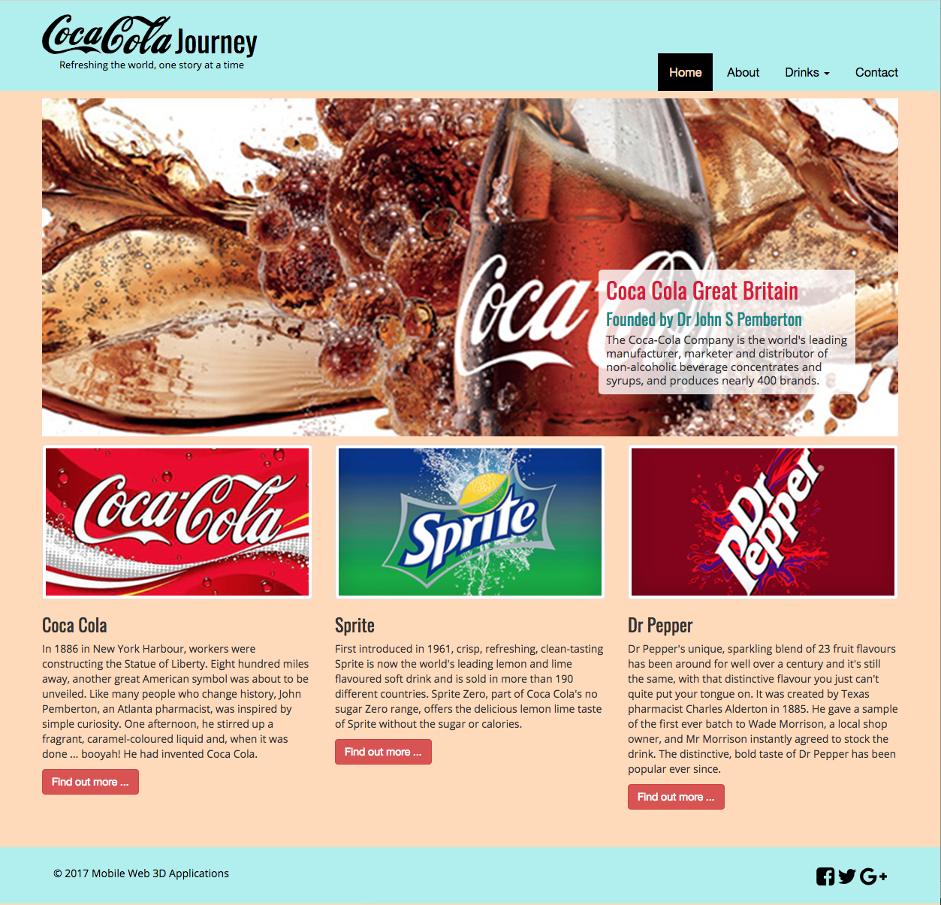

Figure 3: An example comp of the Lab 1 web page layout

So, let’s build your 3D App landing page similar to that shown in Figure 3 — we will use Bootstrap 4.3.

Head on over to the [Bootstrap](https://getbootstrap.com/) site and download the libraries, then install them into your project directory. Don’t forget to have a read around the Bootstrap ‘Get started’ notes and make a decision on whether to use Bootstrap’s managed dependencies, a Bootstrap CDN or a compiled build of Bootstrap’s CSS and JS. We tend to use either a CDN or a compiled build, more usually the compiled build. We suggest you download the **compiled CSS and JS** build.

It should download as a zip file containing a ‘css’ and a ‘js’ folder, which each contain all the variations of Bootstrap CSS and Bootstrap JS that you may need. You will probably need only the bootstrap.js, but you can use the minified version, and I think you should only need the bootstrap.css (or the bootstrap.min.css) versions of the CSS files — but no harm in leaving them all in the ‘css’ folder for now — you can clear out the ones you don’t need later.

**Instruction:** Install the ‘css’ and ‘js’ folder into your project directory at the root, i.e. same level as your assets folder, and while you are doing this add a folder for some fonts in your assets folder, see Figure 4.

As we move forward through the module labs we will build up the assets folder to include other media, e.g. 3D, videos, whatever.

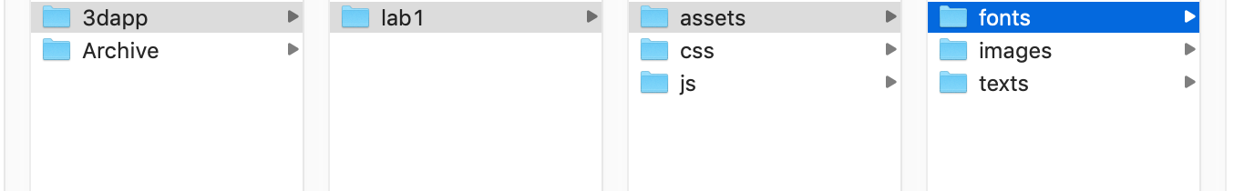

Figure 4: The lab 1 file structure with the new assets/fonts, css and js folders

That is about all we need for now, so let’s open up a code editor to start developing our code and markup. In this tutorial we will use [Visual Studio Code](https://code.visualstudio.com/), see Figure 5 for the Lab 1 site opened in Visual Studio Code. Here, you can see the overall Mobile Web 3D Application module folder structure, which correlates to that shown in Figure 4. You will be building code and creating media assets for Labs 1 through to Lab 7, Lab 8 will be an example of a very basic 3D App, and Lab 9 will be a Coca Cola based 3D App continued as a partially completed Bootstrap version of Lab 6, but exploiting the MVC design pattern, which you explore in Lab 7 and 8. Note, each week you will add lab2, lab3, and so on, folders. AS the labs are completed each week we will usually add these new results to the **Live Feedback Site**.

You can see from Figure 5 that we have installed all the Bootstrap CSS and JS files that we downloaded. However, you only need the bootstrap.css or bootstrap-min.css and the bootstrap.js or bootstrap-min.js. **I suggest to use the bootstrap.js and bootstrap.css versions, because there is some feature we need later that is left out of the min versions!** You can remove the rest or archive them away somewhere, or just leave them where they are for now.

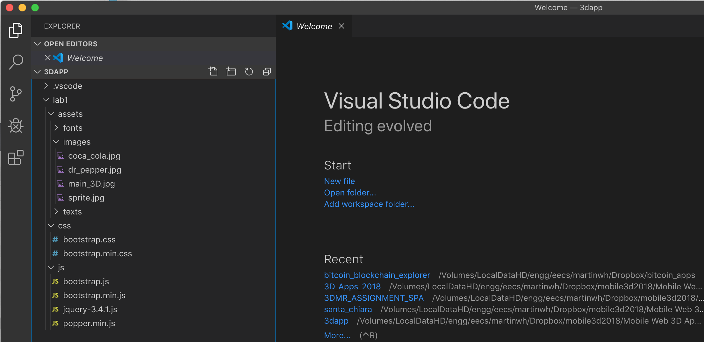

Figure 5: The lab 1 file structure opened in Brackets

We can now start to develop the fluid grid layout in HTML5 using Bootstrap. First we need to get a basic template up and running. If you look on the [Bootstrap Get started](https://getbootstrap.com/) site you will see they have a starter template you can copy.

You will have to do some digging a round to install the libraries for JQuery, popper and Bootstrap. For example, Bootsrap downloads as a zip file and you simply grab the files you need and put them in your css and js folders, while for the Popper and JQuery you can use the CDNs or as we prefer, I simply opened the CDNs and copied the contents into new files and installed in the css and js folder, then tested they worked ok.

Here’s an example that you can use, stick it in your code editor and tidy it up, and save it as index.html, see Figure 6.

<!doctype html>

<html lang="en">

<head>

<!-- Required meta tags -->

<meta charset="utf-8">

<meta name="viewport" content="width=device-width, initial-scale=1, shrink-to-fit=no">

<!-- Bootstrap CSS -->

  <link rel="stylesheet" href="css/bootstrap.css">

<title>Hello, world!</title>

</head>

<body>

<h1>Hello, world!</h1>

    <!-- Optional JavaScript -->

    <!-- jQuery first, then Popper.js, then Bootstrap JS -->

    <!--

    <script src="https://code.jquery.com/jquery-3.3.1.slim.min.js"></script>

    <script src="https://cdnjs.cloudflare.com/ajax/libs/popper.js/1.14.7/umd/popper.min.js"  ></script>

    -->

    <script src="js/jquery-3.5.1.js"></script>

    <script src="js/popper.min.js"></script>

    <script src="js/bootstrap.js"></script>

</body>

</html>

Note, you will see that first we tried out the CDNs for JQuery and Popper, then created the local versions and installed them.

For more details on setting up a Bootstrap template, check out Appendix F. If you decide to use the CDN, you will have an HTML template like that shown in Figure 6, but note the libraries versions have advanced.

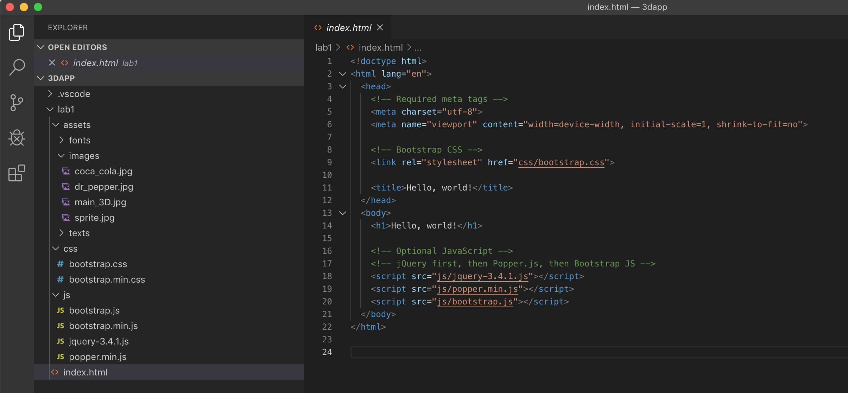

Figure 6: Your new index.html initial template.

So, once you have setup your initial HTML template as shown in Figure 6 check it works on a web server. Here, you can use your Home Share/public_html/lab1 directory as discussed in Part 1, i.e. copy over your file structure to your Home Share/public_html/lab1. In which case, you will access it through something like:

* http://users.sussex.ac.uk/~martinwh/3dapp/lab1/

Your path might be slightly different, for a start use your own username, obviously.

Alternatively, if you are working from home, perhaps on your personal laptop, then you can install a web server such as XAMPP, WampServer for a PC or MAMP for a Mac and check it works on your localhost, see Figure 7, and the path might be:

* http://localhost:8888/3dapp/lab1/

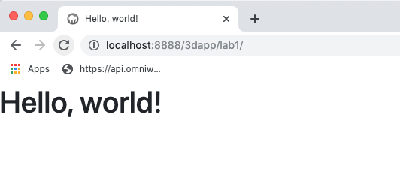

Figure 7: Hello world on your localhost

Clearly, this isn’t an exhaustive test! Ok, let’s get on with creating the page structure, for the comp given in Figure 3, with a fluid grid layout.

## Create a fluid grid page with Bootstrap

Bootstrap’s grid system allows up to 12 columns across the web page, which can be grouped into a wider column, e.g. 2, 4, 6, 12, etc. You do odd columns as well, e.g. 3, 5, 4, and mix it up! Because the Bootstrap grid system is responsive, these columns will re-arrange depending on screen size.

For a more detailed discussion on fluid grid in Bootstrap see Appendix G. Also, here is a very good YouTube video describing Bootstrap fluid grid layouts: [Bootstrap 4 Grid System Explaind!](https://www.youtube.com/watch?v=VaW4na2qkwQ) Note, here they are using Bootstrap 4.0.0-alpha, and they have added some custom CSS.

To design your layout, it is often useful to jump over to somewhere like w3schools and use their Bootstrap [grid examples](http://www.w3schools.com/bootstrap/bootstrap_grid_examples.asp) where you can try out different layouts and then reuse the code. So, if we look at the comp in Figure 3 we can see that we will need a number of block elements that include:

* A header that contains a logo based on text, not an image, and a navigation bar.
* A row that contains a background main image with a floating text box.
* Another row that contains three columns with an image in each.
* Another row that contains three columns with text aligned under each image and a button in each to link to other information. However, in this case we don’t use a Bootstrap row because we want the text to stay underneath the associated image when we shrink to smaller devices. If we make the image 100% width of the column, then the text has to float beneath the image.
* And, finally a footer that contains some copyright information and links constructed from [awesome fonts](http://fontawesome.io/).

The layout is designed to be responsive maintaining the same layout for desktop and larger tablets and rearranging to single column for smaller tablets and mobiles.

Don’t worry about the header and footer yet, focus on the main contents, put these contents in a Bootstrap container class — you can use a Bootstrap container or container-fluid class, but later if you use a container fluid class you will need to make sure you have enough background images for each media query break point. For now, I am going to use a Bootstrap container class.

That should be enough information to go and use the w3schools site to get the grid layout designed. You should end up with something like that illustrated in Figure 8. Try modifying the Mixed: Mobile, Tablet and Desktop example to achieve the layout for the main image and three columns below in the comp.

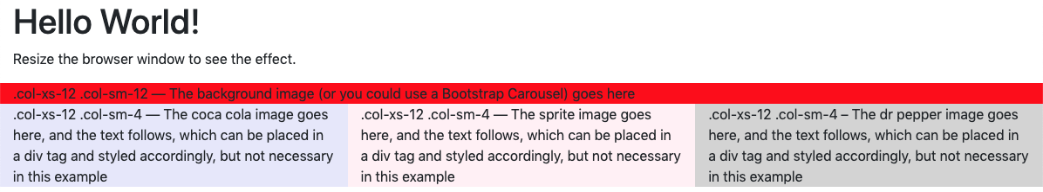 (A)

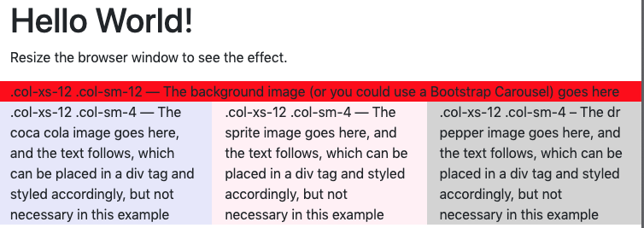 (B)

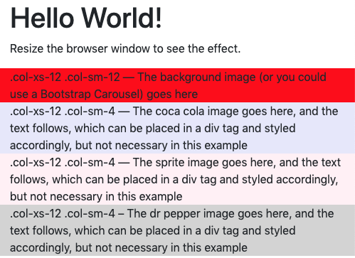 (C)

Figure 8: Lab 1 Bootstrap grid layout (A) desktop, (B) tablet and (C) mobile

If you don’t specify the column width, for example, .col-xs-12, for mobile devices it will use the default of 12 columns, and so on. So, in this example, shown in Figure 8 (C) will stack anyway. Ok, you should now have the basic grid structure for your Lab 1 layout, as far as the main content is concerned anyway. Transfer your code from w3schools into your code editor and check it works.

Figure 9 shows the code transferred from the w3school to Visual Studio Code, you may have a different code editor.

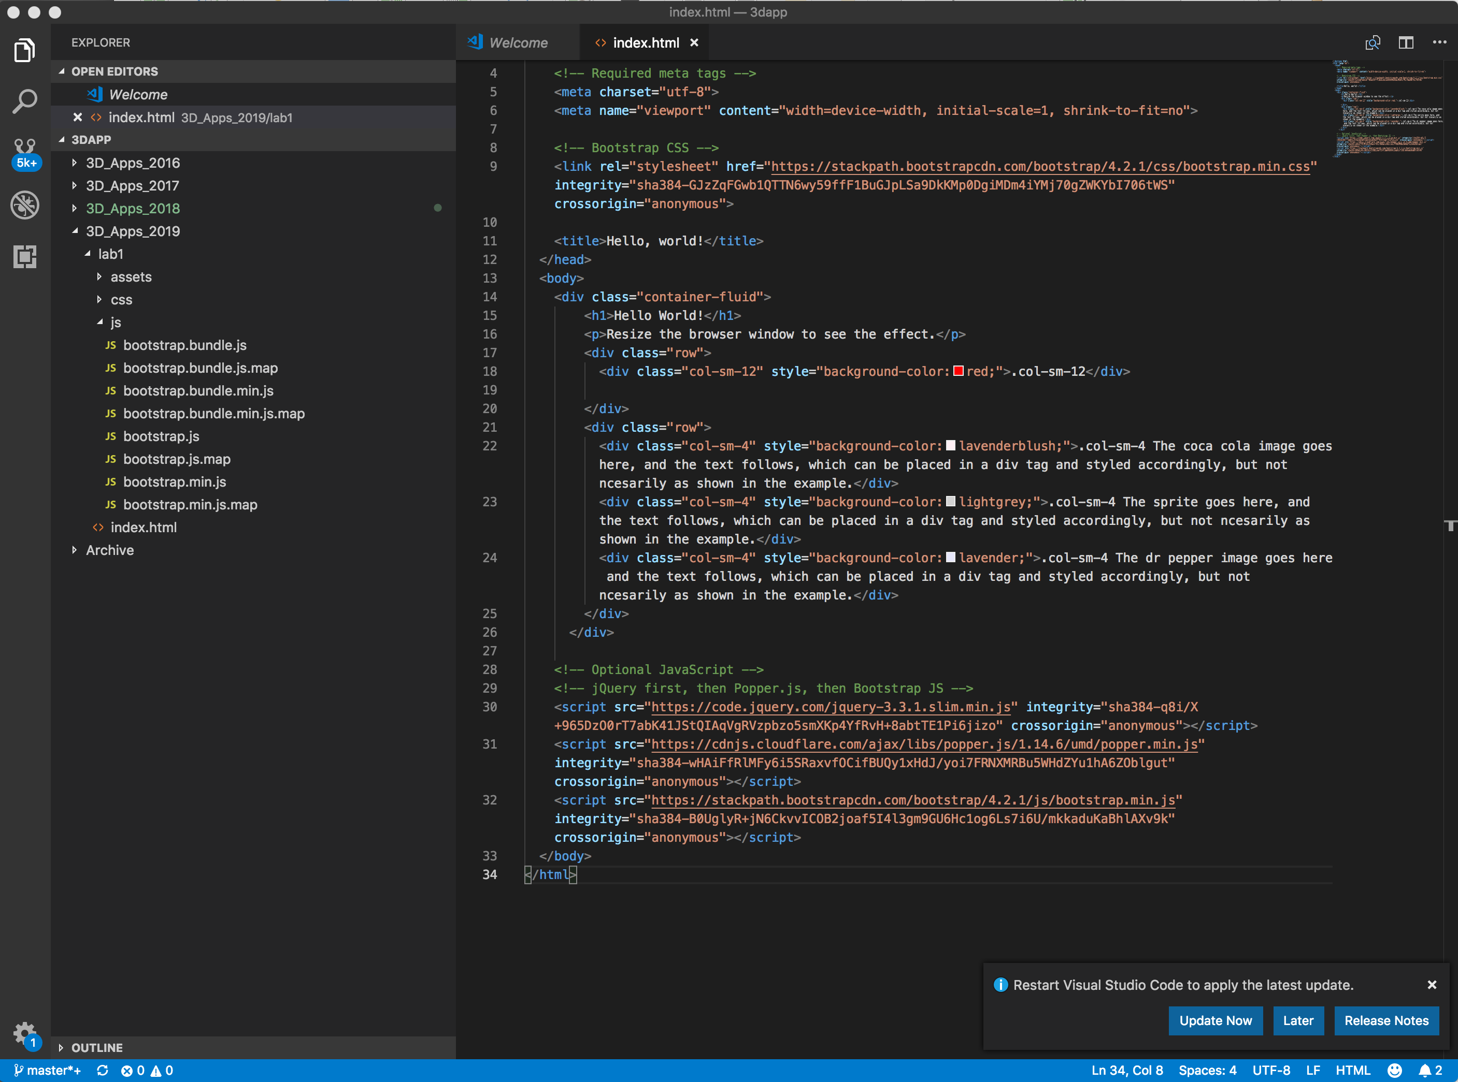

Figure 9: The Bootstrap grid layout for Lab 1

And, just to confirm, save and check your layout in the Chrome web browser, you need to get used to using the [Chrome Developer Tools](https://developer.chrome.com/devtools), see Figure 10

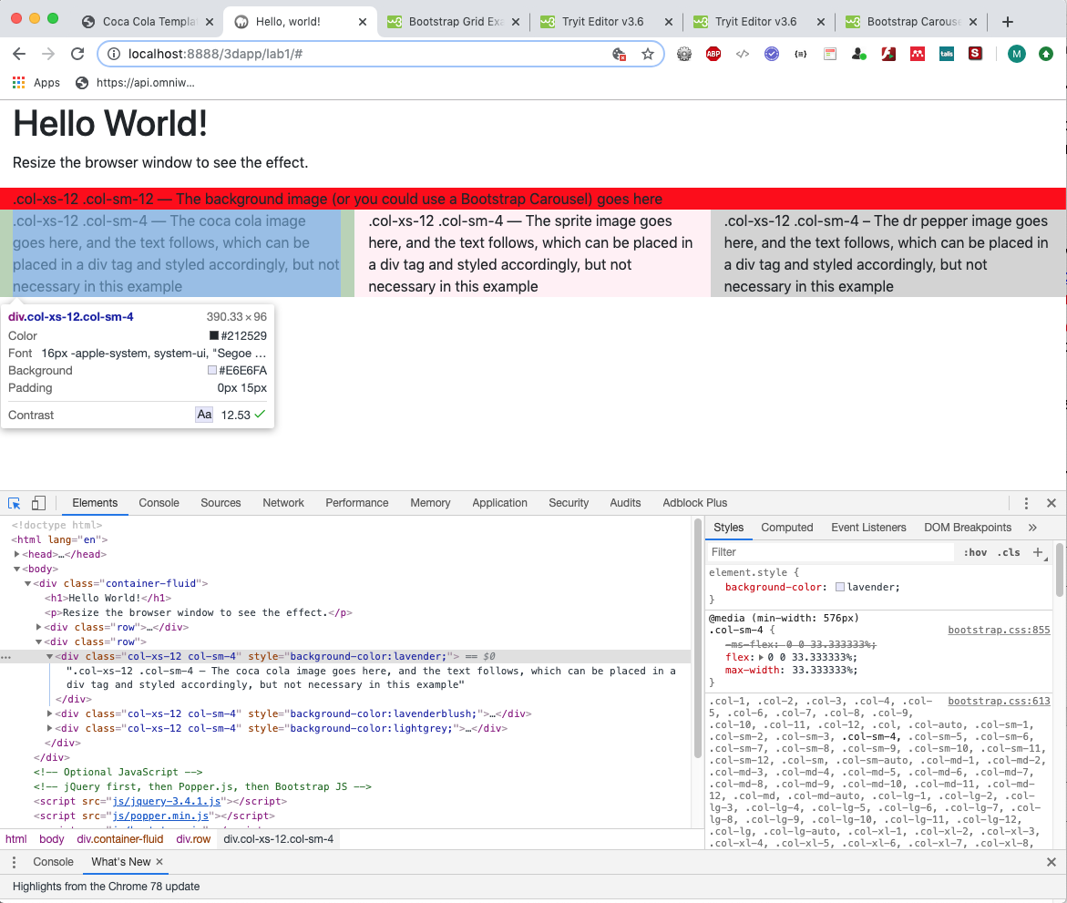

Figure 10: Lab 1 Bootstrap grid layout checked in the Chrome Developer Tool

You need these results before you move on.

## Create the header

If everything is ok so far, we will create the header and footer now, then later on we will create a style sheet to start styling your 3D App landing page. We will start with the Bootstrap header.

Bootstrap has a navigation bar (navbar) class that we can exploit to develop the header, see [Bootstrap Navbar](https://getbootstrap.com/docs/4.3/components/navbar/), (**don’t forget that some of these links may point to previous versions of the Bootstrap component, so don’t forget to navigate to the correct version that you are using**), which you can peel apart or have a play with [w3schools Bootstrap Navbar examples](https://www.w3schools.com/bootstrap4/bootstrap_navbar.asp). I recommend playing with the w3schools for a while to get to know Bootstrap’s navbar class better, particularly the Brand /Logo, Collapsing The Navigation Bar, and Dropdown menu examples..

So, once again looking at the comp in Figure 3, which shows the required Lab 1 page layout including the need for a logo on the left-hand side and a simple navigation menu. What is not shown, and what we have to consider, is how the navigation menu will display on smaller devices where this menu may not fit. In this case, it is common to use, what is often called a 3-bar icon menu, which when clicked drops down a menu to fit the smaller device — see the [Collapsing the Navigation Bar](https://www.w3schools.com/bootstrap4/bootstrap_navbar.asp) example on w3schools, but we will get to this later.

Let’s get the basics of the header container inserted first, then repeat more or less the same for the footer before we delve into the header and footer contents. If we look on w3schools navbar examples, they have a nice Navbar With Dropdown example that we could use as an initial basis for our header navbar. By comparison with the comp in Figure 3 and modifying the code in the w3schools examples, see Figure 11.

You can see here that we have modified the w3schools example to produce a simplified logo, we will expand that later and style it, etc. and utilize a list with a Bootstrap dropdown class for the navigation menu and shunt it right. Bootstrap virtually does it for you, but the key is really to re-style it into your own design. Often, you see sites where they don’t do this and it has that Bootstrap signature look and feel, which is not necessarily what we want! Certainly, if I had paid a web designer to build me a site I would want it looking like my site, not Bootstrap’s! But, we will sort the styling out later, Bootstrap default is fine for now. Also, later we will add the 3-Bar icon navigation for mobile devices.

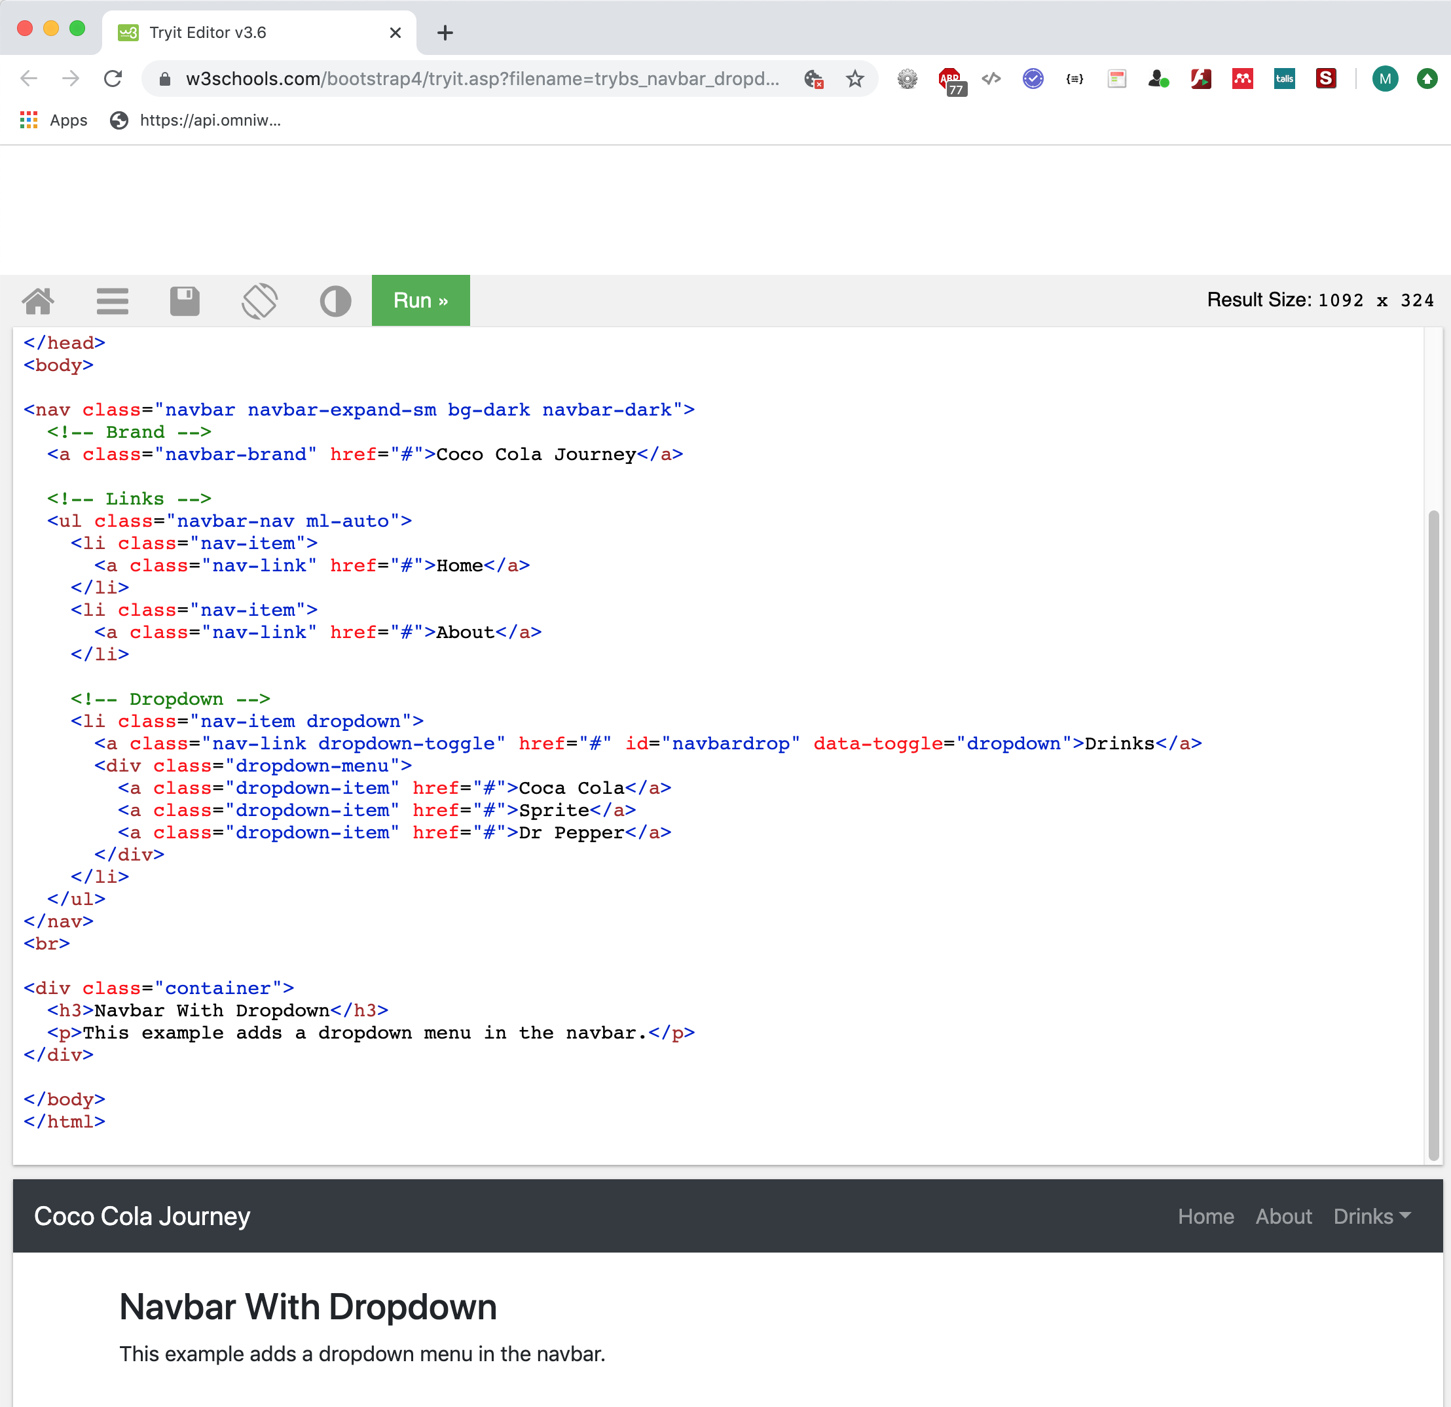

Figure 11: Modify the w3schools navigation bar with dropdown.

Also, Bootstrap 4 has a set of [Bootstrap Navs](https://www.w3schools.com/bootstrap4/bootstrap_navs.asp) components and as w3schools says, to use this all you need to do “to create a simple horizontal menu, is add the .nav class to a <ul> element, followed by .nav-item for each <li> and add the .nav-link class to their links”. However, as shown in Figure 11 we used the [Navbar With Dropdow](https://www.w3schools.com/bootstrap4/tryit.asp?filename=trybs_navbar_dropdown&stacked=h)n example for w3schools. [Bootstrap Navs](https://www.w3schools.com/bootstrap4/bootstrap_navs.asp) components may be useful later for page content navigation?

The code in Figure 11 is virtually the same as the example given by w3schools, except that I have changed the link texts, logo text, added a new link, and changed the drop-down text labelled, etc. The other key thing is that I have shunted the navigation over to the right. The attribute to do this the ‘ml-auto’ (margin-left auto) attribute, part of [Bootstrap Spacing Utilities](https://www.codeply.com/go/kaWaobOUD8), which you should add to the navbar-nav class.

So, transfer your w3schools code over to your code editor before you lose it, and test it, see Figure 12.

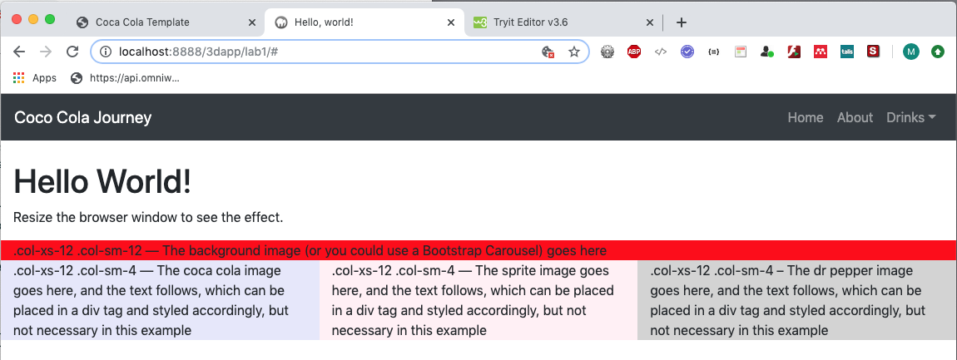

Figure 12: Creating the basic header for our Lab 1 site.

If you test this in the Chrome Developer Tools or simply reduce the browser size to roughly a tablet or mobile size, see Figure 13 you will see that the dropdown menu display in the smaller size. Here, I have opened the drop down too. Things are happening, Bootstrap 4 is doing the heavy lifting, we just need to start manipulating it.

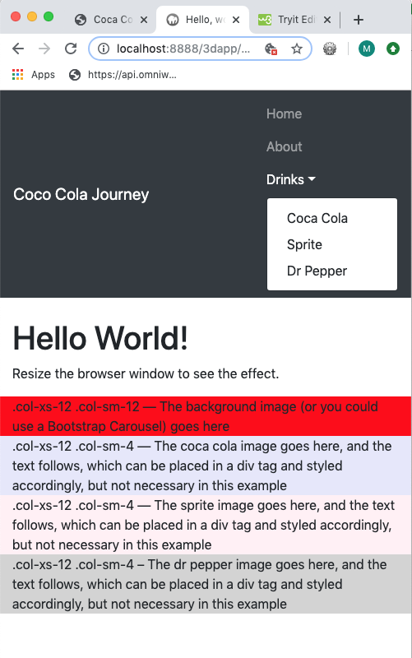

Figure 13: Dropdown menu displayed in a smaller device size.

Let’s start by hiding and revealing this navigation menu using the 3-bar icon approach discussed above. We’ll add that code next.

### Convert the navigation menu to a 3-bar icon

A common way of handling a menu on smaller devices, such as a mobile or small tablet is to create an icon of some sort such that when clicked it opens and closes a dropdown menu. There are arguments for and against the use of a 3-bar icon (or menu hamburger), and you can use some other icon, or method of producing such — see Appendix H for further details.

**Note:** At some point it will be useful to get hold of the font awesome fonts, so download [Font Awesome 5](https://fontawesome.com/?utm_source=font_awesome_homepage&utm_medium=display&utm_campaign=fa5_released&utm_content=download_modal). You can set up an account, you will then get your specific kit such as

<script src="https://kit.fontawesome.com/6ac3910c4e.js" crossorigin="anonymous"></script>

Alternatively, you can use last year’s version, which you can harvest from the **Live Feedback Site** and install them in your fonts folder.

But, you may prefer to host yourself the latest versions, in which case go to navigate on the font awesome site to the download page and **Download Font Awesome Fee for the Web**.

You will get a zip file from which you need to extract all.css, all.js and webfonts. The download page (**Hosting Font Awesome Yourself**) instructs you how to install. Also, they indicate how to use them, do have a read of the font awesome site to become more familiar.

Continuing from above to develop the three bar collapsing icon for the navigation, for now we will simply use the w3school’s example of Bootstrap 4 [Collapsing the Navigation Bar](https://www.w3schools.com/bootstrap4/tryit.asp?filename=trybs_navbar_collapse&stacked=h). Check it out and port it into your code, see Figure 14.

However, rather than use the ID for the data-target in the w3school code, switch it to target the .nav-bar-collapse class instead.

<button type="button" class="navbar-toggler" data-toggle="collapse" data-target=".navbar-collapse ">

<span class="navbar-toggler-icon"></span>

</button>

Doing it this way will allow us to apply some CSS styling to the icon button more consistently than using an ID, but we will look at this later, let’s get the functionality working first.

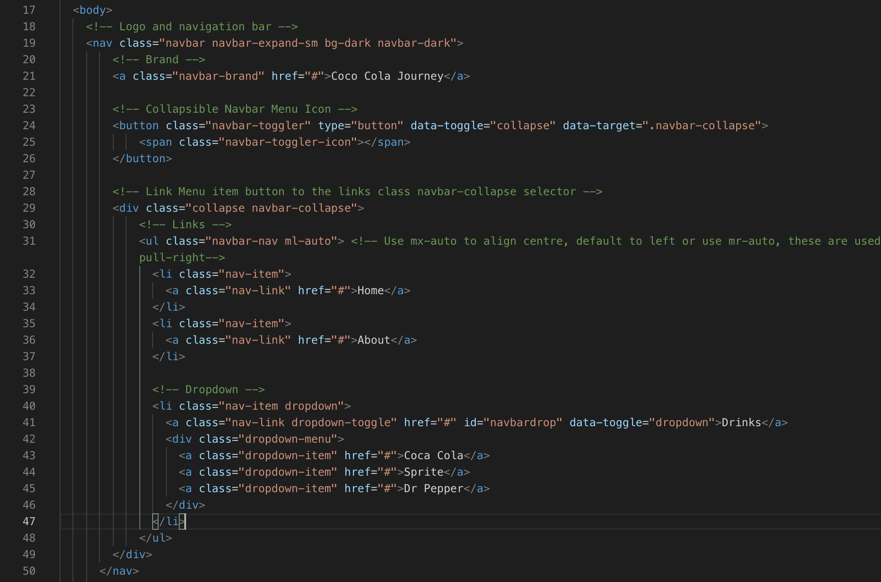

Figure 14: Add the Bootstrap 4 collapse navbar code

You can see that we have simply created a HTML5 button and used the [Bootstrap’s Navbar](https://getbootstrap.com/docs/4.3/components/navbar/). In our example, above you can see that we are using the toggle and collapse classes to allow the navigation menu to switch to the hamburger menu for small devices. You will also need to wrap the navigation menu in the navbar-collapse class because this is the target for the navigation menu collapse.

When you collapse the screen size towards a small tablet or mobile screen size you should see the navigation menu disappear to be replaced by the hamburger menu button, see Figure 15.

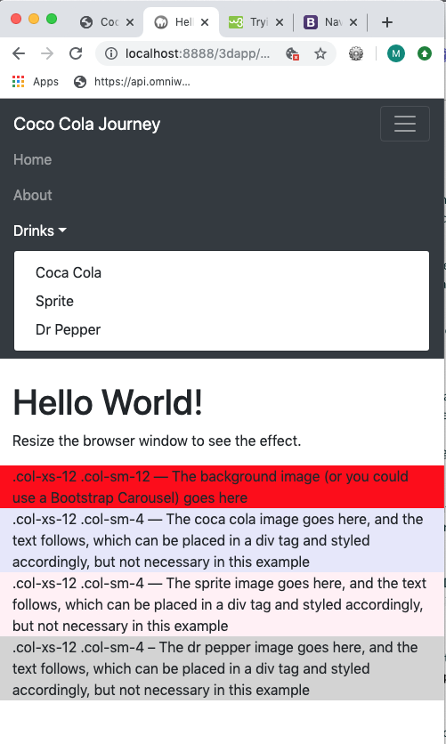

Figure 15: Small screen size showing menu icon and opened menu

Finally, let’s make the Home nav-link active with the .active class; modify the code in Figure 14, see Figure 16.

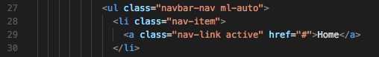

Figure 16: add the .active class to the Home menu link

The Home link should appear active now, i.e. appear highlighted.

## Create the Footer

In a similar way, we can create the footer. Here, I will simply give you the code and explain it. You should have already installed the fontawesome libraries, ether in your assets/fonts folder or as a CDN file, now we can see if it works, see Figure 17.

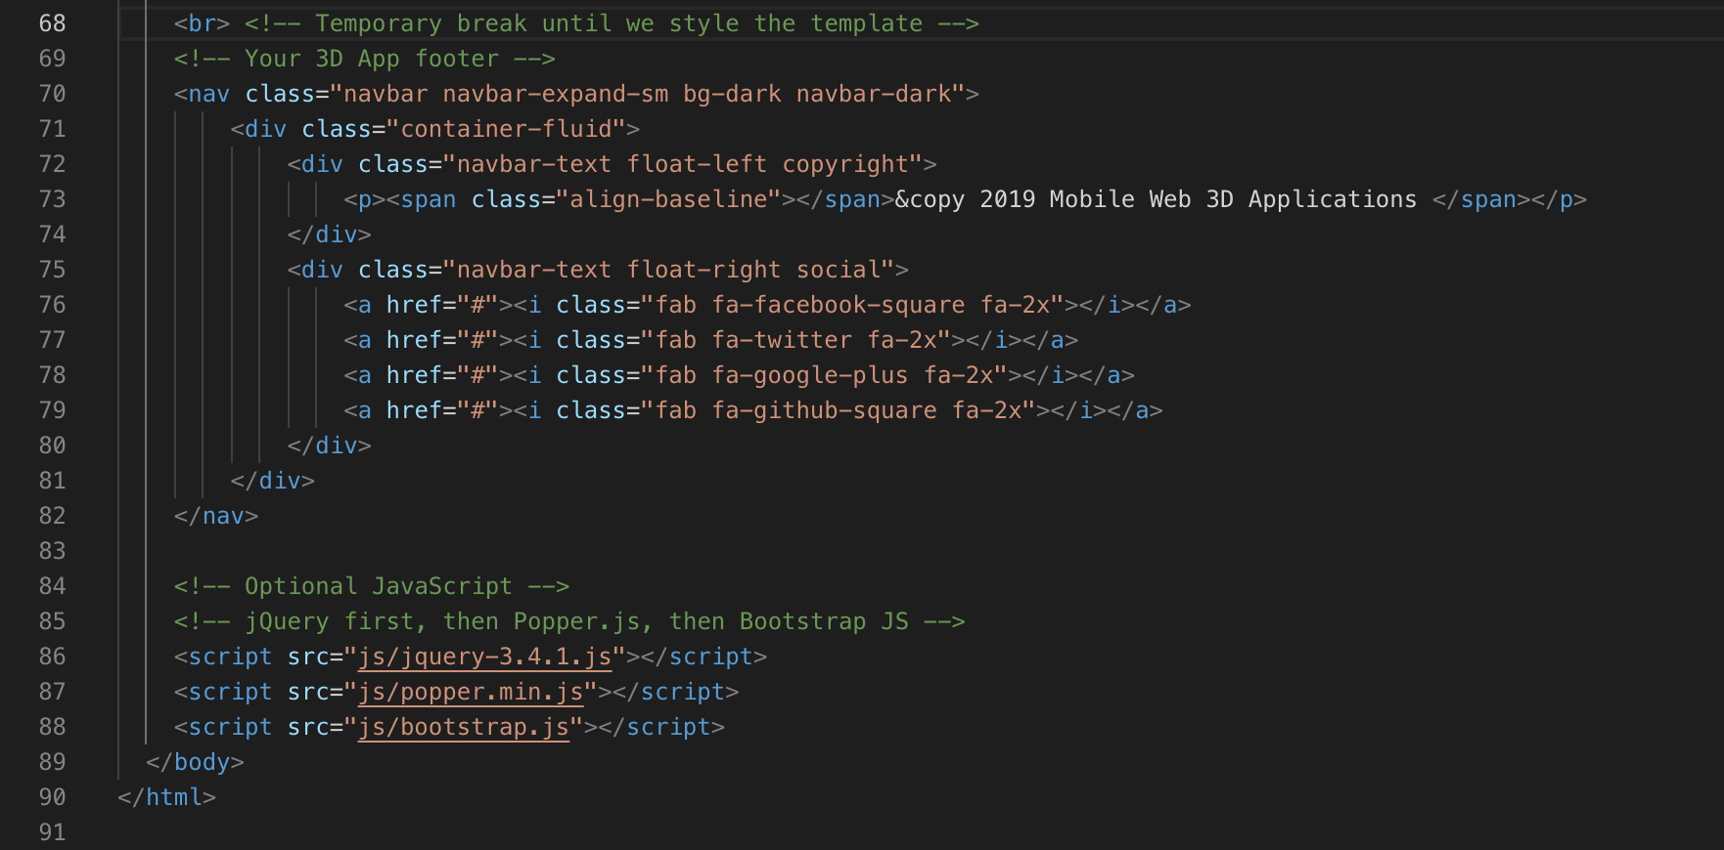

Figure 17: Some HTML5 code to construct a basic footer

Notice here that we have just popped in a temporary break so that the footer does not jam up against the main contents, this is because we haven’t styled anything yet. Put a temporary break between the header navbar and the main contents too.

As you can see, we have simply used the Bootstrap navbar again. Put the footer contents in a container-fluid, you could also have used a container — this will move left and right contents in from the left and right edges. After you have completed the template you could switch the header, main contents and footer containers for container and see what you prefer. For the moment, stick to using the container-fluid class.

You can see that we have simply created content for copyright information on the left-hand side and placed this inside a navbar-text class and floated it left, and on the right-hand side created some links with font awesome icons, floated right (note for the header nav-bar navigation menu, we had to use ml-auto to move the menu to the right). Both these contents will be styled later. Figure 18 illustrates the complete code so far.

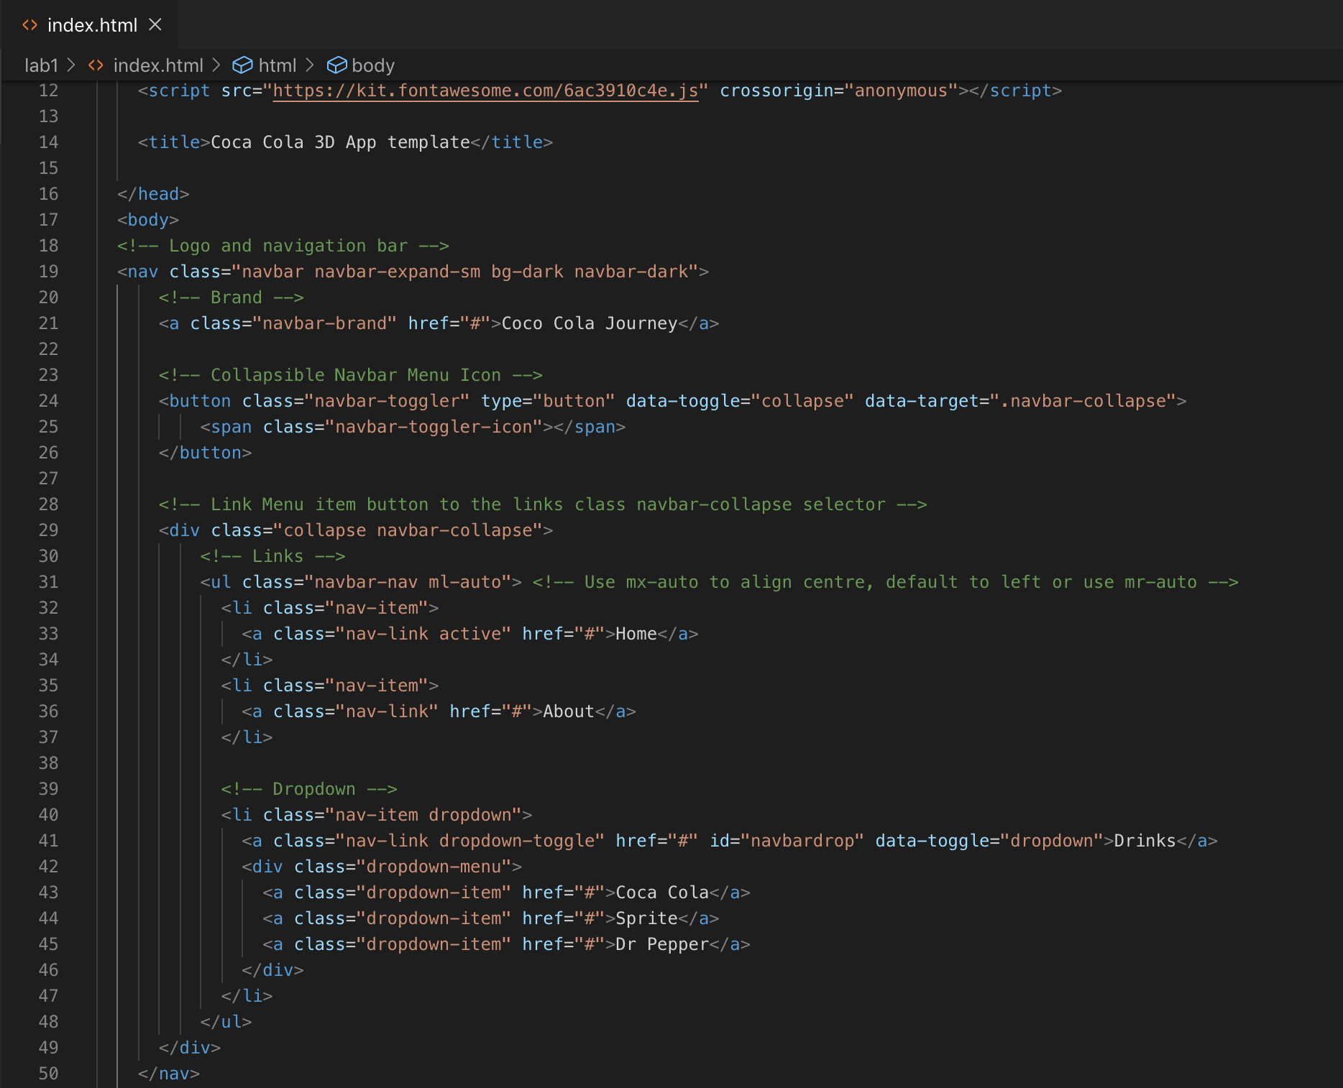

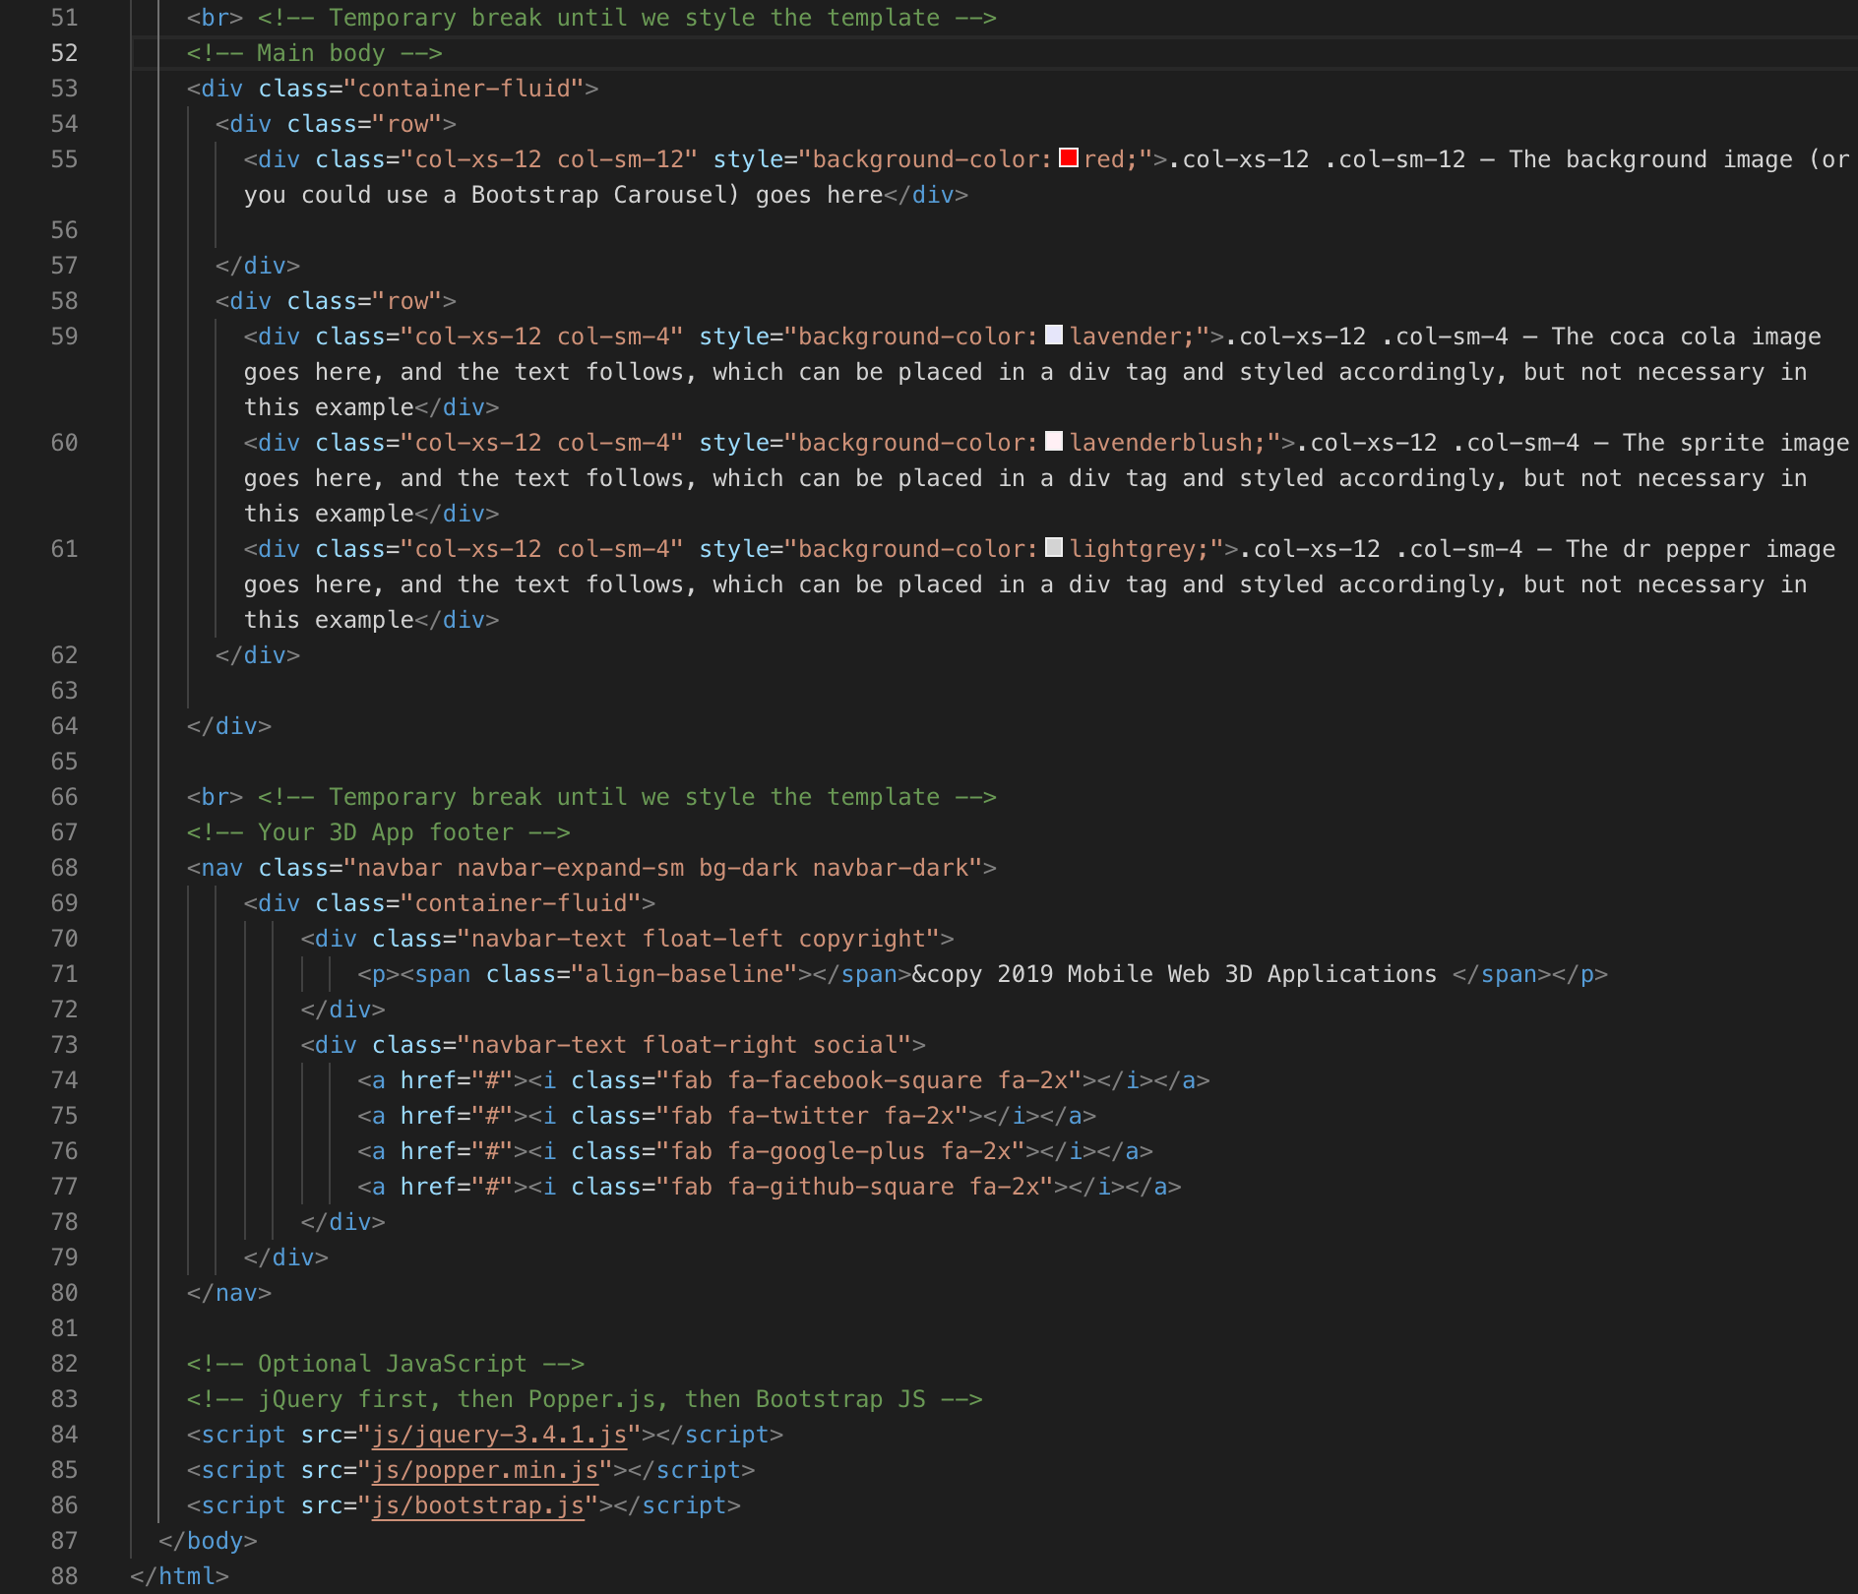

Figure 18: Complete code so far

You should have an HTML5 Bootstrap template that looks something like that shown in Figure 19.

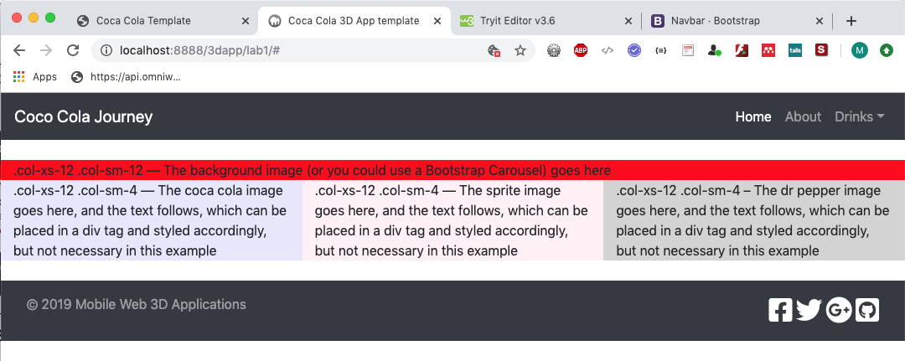

Figure 19: The basic HTML5 Bootstrap template so far

Clearly, all styling is defaulted to whatever we choose in Bootstrap and font awesome so far. Later we will start to write some CSS3 code to overwrite this default look. We will insert the main contents next and leave most of the styling until last.

You should also try out the container class, see Figure 20. You will need to add a div block after the header navbar to scope the logo and navigation menu and add the .container class. For the main contents and footer, you only need to change container-fluid to container.

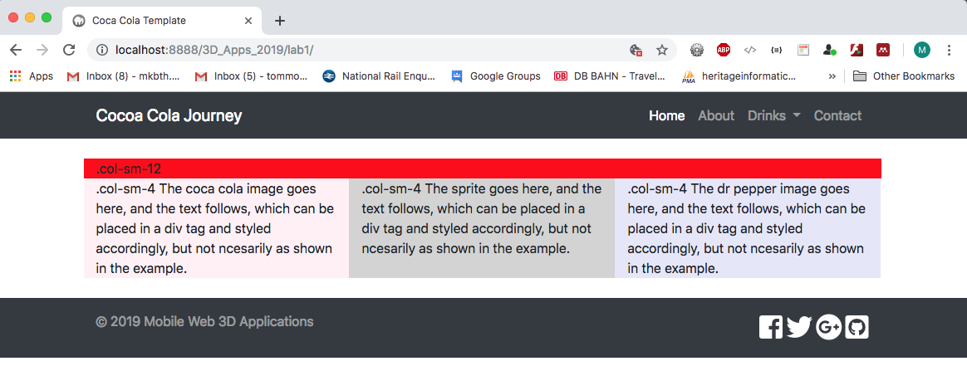

Figure 20: Added .container class to the header and changed contents and footer to .container class

As the comp in Figure 3 looks like it is calling for the .container class, I’ll leave it like this for now. But, we may change it back later.

# Part 3 Insert the laboratory 1 contents

You should already have downloaded the images and text, which are the main contents for the Lab 1 page, and you should have placed these into their corresponding assets folder: /image/ and /text/. The image assets you should have are indicated in Figure 21.

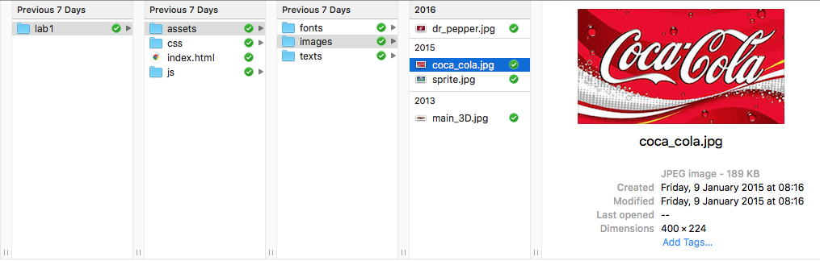

Figure 21: Lab 1 site structure so far

So, you should have 4 images: coca_cola.jpg, dr_pepper.jpg, sprite.jpg and a main_3D.jpg image — these images are currently 316x117 pixel resolution, which is a bit small for the larger desktop screen size. You should use Photoshop CC to scale them up to something like 400x224 resolution. Later on you will need to use Photoshop to create a set of images of the main_3D.jpg image for each of the device screen size breakpoints. For the moment, although we are creating a mobile first lab 1 site, the main_3D.jpg image you have been given is more suited to a desktop layout. So, in this case we will insert these contents with our browser roughly sized to something we might view on a desktop. Then we will start to build the custom.css file to style for mobile first. You should also have the text given located in the text folder. For lab 1, we are simply going to insert the text into the HTML5 file for now.

Later, around lab 4 or 5 we will place the text in a JSON format and access it asynchronously using [AJAX](https://www.w3schools.com/xml/ajax_intro.asp) with the [jQuery.getJSON() function](https://api.jquery.com/jquery.getjson/).

### Insert the image content

Let’s start by inserting the 3 images: coca_cola.jpg, dr_pepper.jpg, sprite.jpg because the main_3D.jpg image is going to be used as a background image and is referenced by its URL in the custom.css file when we develop the CSS. There are a number of ways to insert and style images using CSS, for more details see Appendix I.

However, we will use Bootstrap [Cards](https://getbootstrap.com/docs/4.3/components/card/) to embed our images. Where “a card is a flexible and extensible content container. It includes options for headers and footers, a wide variety of content, contextual background colors, and powerful display options. If you’re familiar with Bootstrap 3, cards replace panels, wells, and thumbnails”[1]. This coupled with Bootstrap responsive [Images](https://getbootstrap.com/docs/4.3/content/images/) thumbnails class will allow plenty of scope for handling images in the site page. Figure 22 illustrates the content images inserted with the Bootstrap card component.

Notice that the card component puts a 1-pixel boarder round the card, which we can remove by overwriting its CSS later, if desired, and gives us a card body with title and text areas.

Further, Bootstrap [Spacing](https://getbootstrap.com/docs/4.3/utilities/spacing/) “… includes a wide range of shorthand responsive margin and padding utility classes to modify an elements appearance”[2]. We may use these later to set margins and padding for page elements, etc. For example, rather than remove the card class border, as discussed above, we could set a margin between this border and the images. We will look more carefully at this in Part 4.

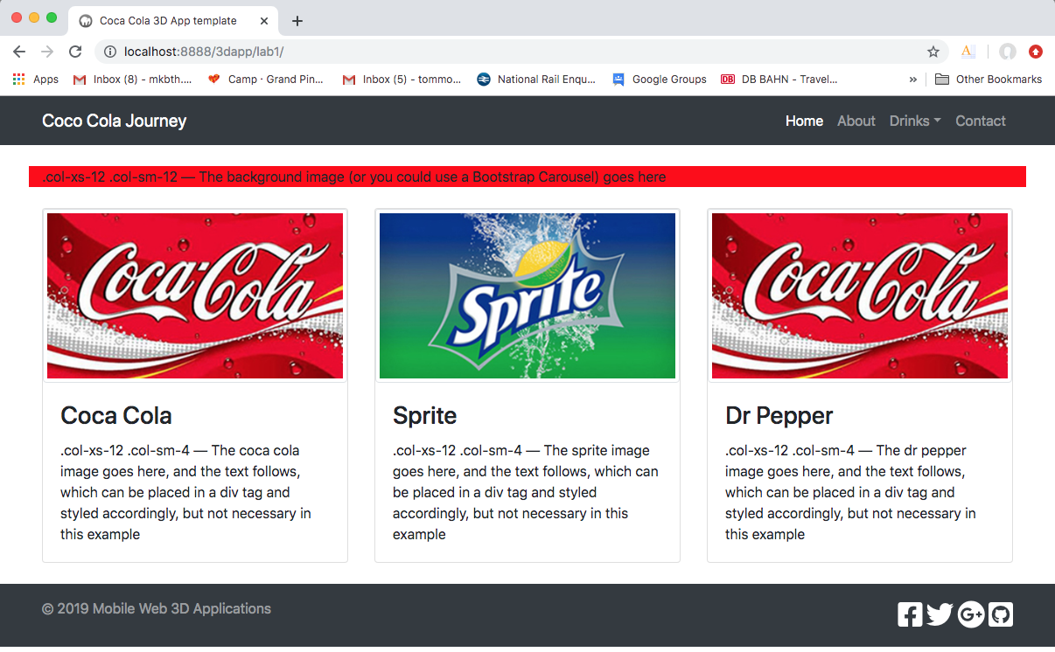

Figure 22: Inserting contents using the Bootstrap 4.2 Card

The code for the Bootstrap 4.3 [Cards](https://getbootstrap.com/docs/4.3/components/card/) component is illustrated in Figure 23. We use the card 3 times. So, you only have to write it once and copy it again, changing the appropriate context. Notice that we use both img-fluid and img-thumbnail from the Bootstrap 4.3 responsive [Images](https://getbootstrap.com/docs/4.3/content/images/) thumbnails class and we use card-img-top to put the image at the top of the card.

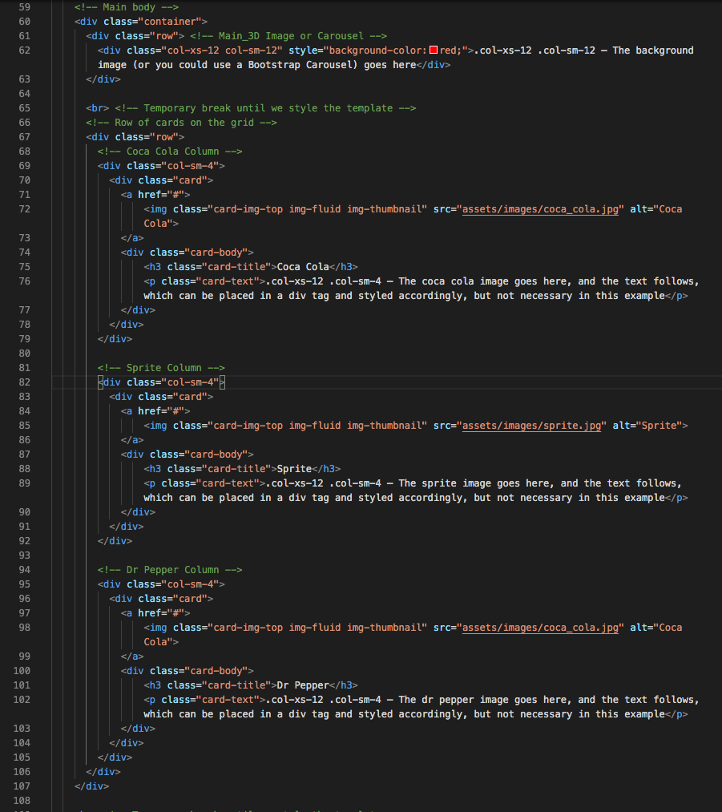

Figure 23: Bootstrap 4.3 card component used 3 times in the main contents

Next, let’s replace the text associated with each of these images, we have used <h3> to format the heading, and <p> to format the text for now, see Figure 23. Later, you will create CSS classes that overwrite the standard HTML h and p tags. You will also add a Bootstrap button below each piece of text:

<h3>Coca Cola</h3>

<p>In 1886 in New York Harbour, … </p>

<a href="#" class="btn btn-primary">Find out more ...</a>

Add this code to your index.html file now, you should find the text in your assets folder. Further, edit the text to get roughly equal sized blocks. After inserting all three pieces of text you should have a result looking like that shown in Figure 24.

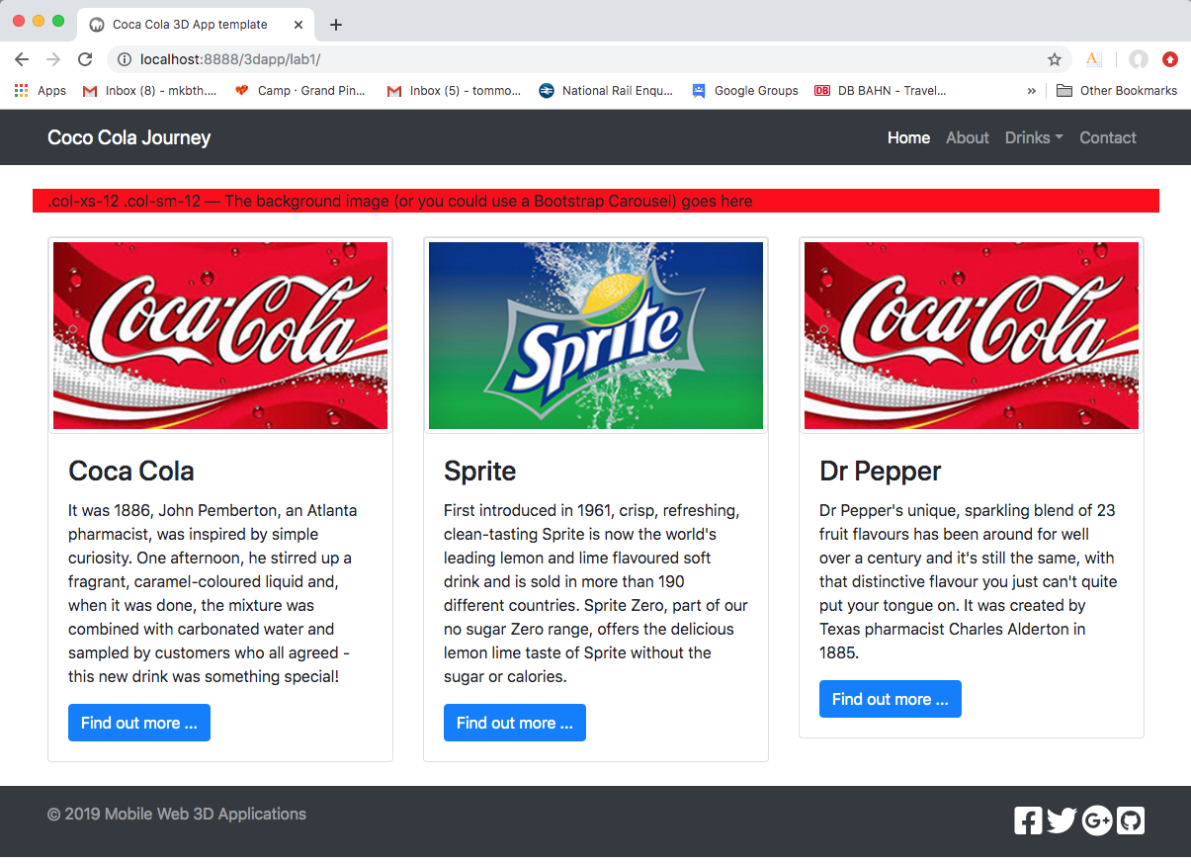

Figure 24: Insert the text contents and the three buttons

We can see that the overall design, as laid out in the comp, see Figure 3, is starting to come together, and we haven’t written a bit of CSS styling yet! That’s Bootstrap doing the heavy lifting so far, with the exception of the default <h3> and <p> HTML5 tags. We can see from the code that Bootstrap gives us a btn class to create buttons, you can read about the button components on the [Bootstrap Buttons](https://getbootstrap.com/docs/4.3/components/buttons/) page. And, as usual, w3schools offers lots of ‘try it now’ [button](https://www.w3schools.com/bootstrap4/bootstrap_buttons.asp) and [button group](https://www.w3schools.com/bootstrap4/bootstrap_button_groups.asp) examples, which will come in handy for your assignment.

The final piece of main content to add is the main text. This will be placed in the main 3D block element. This is the first row we created, the one with the red background colour. Replace the first row with the following code (HTML5 markup):

<div id="main_3d_image">

<div id="main_text" class="col-xs-12 col-sm-4">

<h2>Coca Cola Great Britain</h2>

<h3>Founded by Dr John S Pemberton</h3>

<p>The Coca Cola Company is the world's leading manufacturer, marketer and distributor of non-alcoholic beverage concentrates and syrups, and produces nearly 400 brands.</p>

</div>

</div>

Figure 25 indicates where to insert the main text contents. Note that we have created another div tag here with an id=”main_3d_image”. We will use this id selector to tell HTML5 where to insert the main_3D.jpg background image when we write the CSS rules for this in the custom.css file. Similarly, we will write custom CSS rules to modify the default CSS styles for the <h2>, <h3> and <p> tags using the id=”main_text” id selector. You can also see that we have decided to make the width of the main text to 12 columns for mobile (xs) and reduce to 4 columns for tablets and above (sm).

<div id="main_text" class="col-xs-12 col-sm-4">

This will become clearer when we develop the custom.css file.

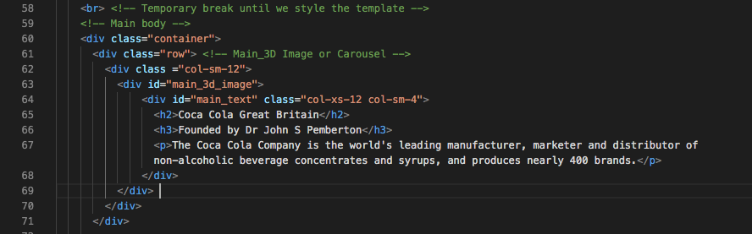

Figure 25: Insert the main text contents in the first row

Our custom.css style rules will also position the main text to float over to the right-hand side of the first row when using a tablet or desktop. Further, we will use the same approach to style the logo, i.e. we will put a div tag around the around the logo with a id=”logo” selector so we can target the logo text for styling.

Your results so far should look something like that shown in Figure 26.

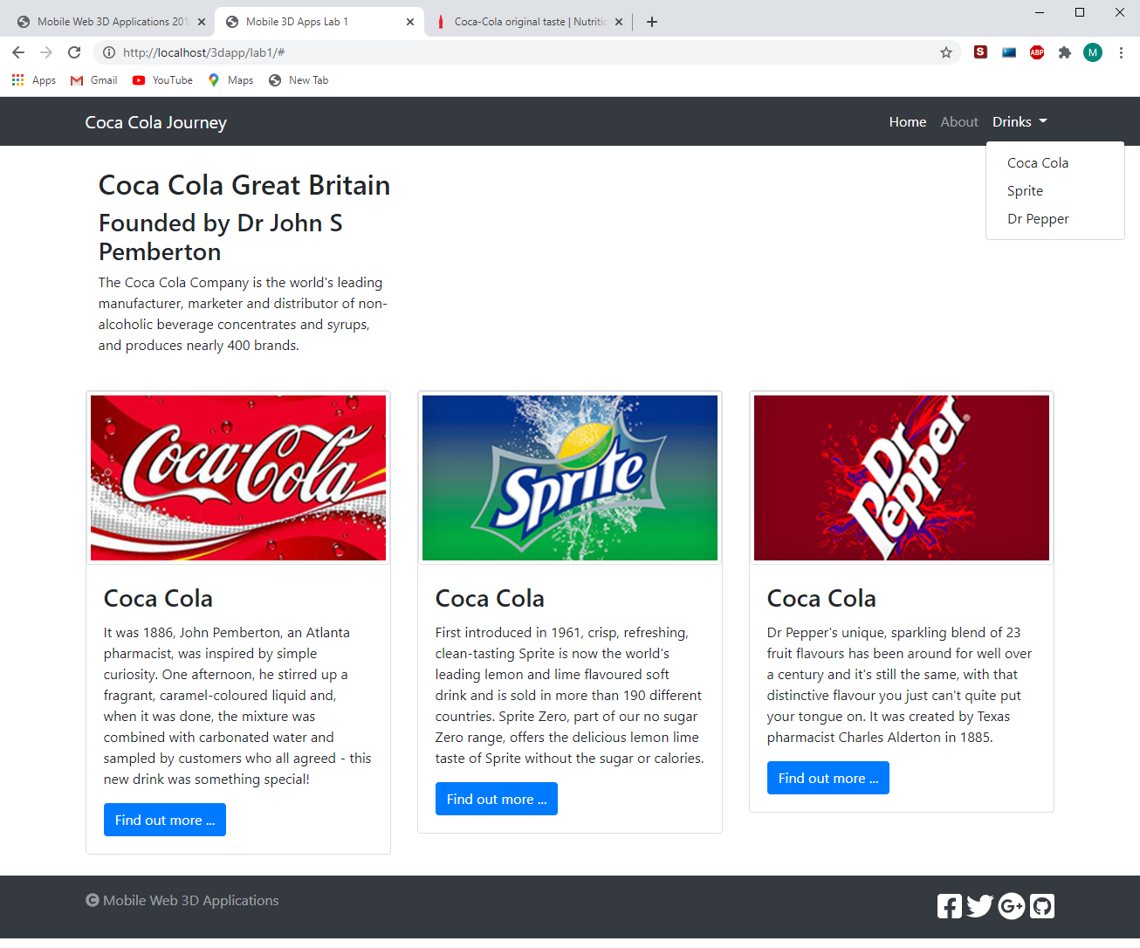

Figure 26: Results after inserting the Coca Cola Great Britain and associated text

Apart from the main_3d_image, we have all the components in place for the home page template now. Check everything is ok, if so, we should start developing the custom.css file next.

# Part 4 Create the CSS styling rules

If we look more carefully at our current result, see Figure 26, before we start to create the CSS rules to style our mobile first web page we can list the main CSS style rule requirements.

1. Header

* We need CSS rules to style the logo to create our coca cola brand, navigation menu, and the header overall, e.g. set the height and colour.

1. Main contents

* We need CSS rules to style the main_3D image, the overlaid main text, the three drinks images, and the associated drinks text.

1. Footer

* We need CSS rules to style the copyright information, the right-hand side font awesome links, and the footer background colour and height.

1. Branding

* And, of course, we need an overall brand, the Coca Cola brand, not the typical Bootstrap default brand; although interestingly the Coca Cola header in 2021 seems to look a lot like Bootstrap!

## Responsive web design – CSS3 media queries

What is a CSS media query? Put simply, the @media rule or query is used to define different style rules for different sized screen devices. It allows us to change the style, or brand even, across your mobile, tablet, desktop, etc.

For further discussion and pointers to various discussions around the use of CSS3 media queries used to achieve responsive web design and whether we should design for screen breaks associated with device sizes, or design around content specific break points and so on see Appendix J.

You will be building a mobile first responsive design, which effectively means you will design a layout for mobile first, then apply different CSS rules through @media screen breaks, thereby adjusting layouts for the larger screen sizes.

We will specifically use Bootstrap’s media query breakpoints. Bootstrap has 6 breakpoints chosen to hold containers whose widths are multiples of 12, see Figure 27.

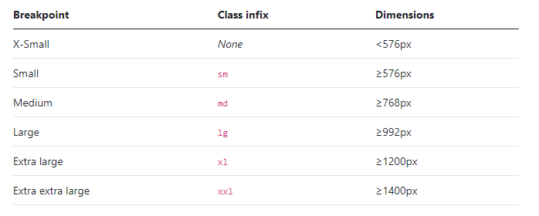

Figure : Bootstrap breakpoints

Bootstrap Layout sets out responsive breakpoints for your custom.css file. You can go to the [Bootstrap](https://getbootstrap.com/) Docs page and search for breakpoints.

/* X-Small devices (portrait phones, less than 576px)

   No media query for `xs` since this is the default in Bootstrap

*/

/* Small devices (landscape phones, 576px and up)*/

@media (min-width: 576px) { ... }

/* Medium devices (tablets, 768px and up) */

@media (min-width: 768px) { ... }

/* Large devices (desktops, 992px and up) */

@media (min-width: 992px) { ... }

/* X-Large devices (large desktops, 1200px and up) */

@media (min-width: 1200px) { ... }

/* XX-Large devices (larger desktops, 1400px and up) */

@media (min-width: 1400px) { ... }

Create a custom.css file save it in your /css/ directory, then copy these media screen breaks to your custom.css file ready to start writing the CSS code.

## Create the CSS rules for the mobile main contents

Before we start creating the CSS rules for the mobile main contents, we suggest that you scale your current design in Chrome down to something that looks like a mobile screen size; you can simply scale the browser or use the Chrome Development Tool and select iPhone 6, 7, 8, Plus or X, see Figure 28.

So, what CSS rules to style this mobile view? We need to create CSS rules for the text, 2 different sets of rules for the main text and the image text. We also want to add in the main_3d_image.jpg, i.e. the background image. In addition, we need to create a coca cola font family and overwrite the Bootstrap CSS rules that style the HTML5 body tag. Therefore, we need to create CSS rules attached to selector IDs or classes for:

#main_3d_image,

#main_text,

p,

h1, h2, h3, h4, h5, h6,

.img-thumbnail

That should provide adequate styling for the main contents of the Lab 1 web page result.

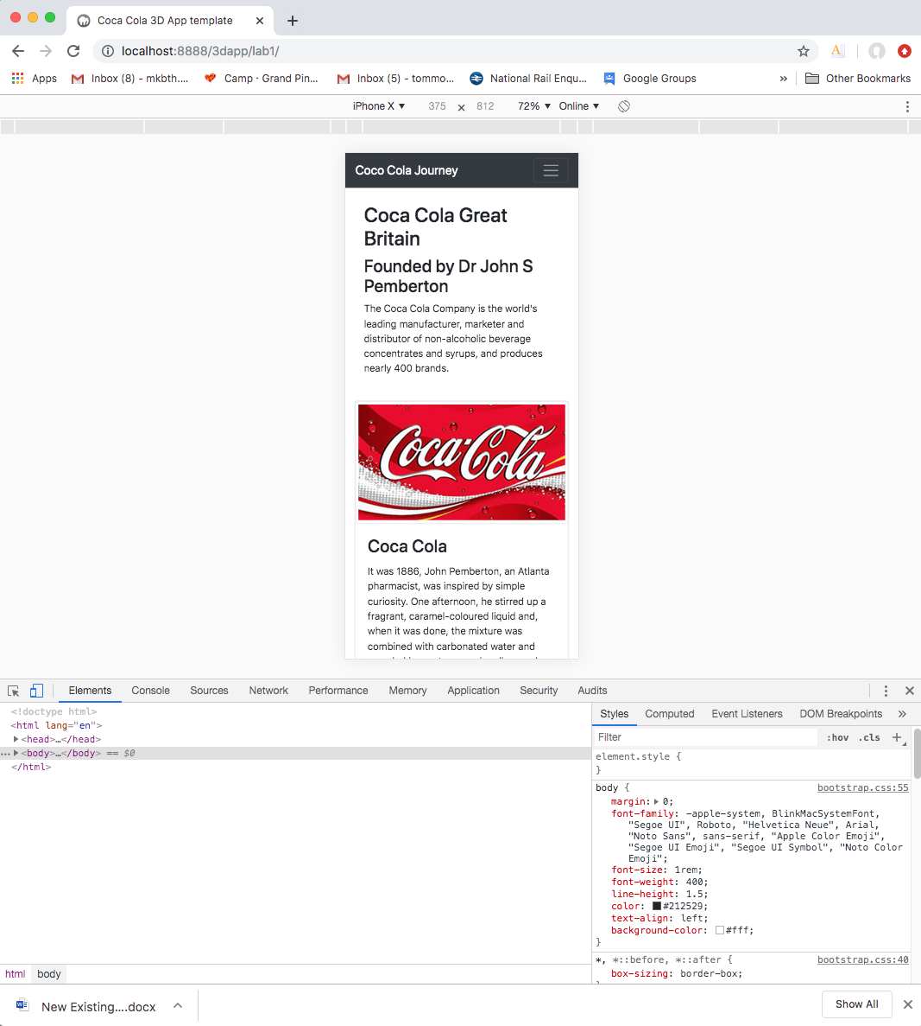

Figure 28: Chrome developer tool with iPhone X selected

### Install and declare fonts

You might like to check out this video tutorial on the two ways to [import new fonts into your website](https://www.youtube.com/watch?v=Hwq_Mr12bcI). Further, w3school highlights [web safe font combinations](https://www.w3schools.com/cssref/css_websafe_fonts.asp).

We will start by creating our own font. Right at the very the top of your custom.css file insert the @font-face rule to declare the coca cola fonts.

/* Method to declare your own fonts */

@font-face {

font-family: cocaColaFont;

src: url(../assets/fonts/loki_cola/LOKICOLA.TTF);

}

/* Extra small devices (portrait phones, less than 576px)

No media query since this is the default in Bootstrap

*/

You will need to download the [lokicola true typeface fonts](https://www.dafont.com/loki-cola.font). Then save them in your assets/fonts/ directory. Make sure that this path is correct.

You can test the font family, i.e. LOKICOLA.TTF, if you wish by simply creating a CSS rule for the p, h1, h2, h3, h4 anh5 and h6 and then applying the font. Try it.

/* Extra small devices (portrait phones, less than 576px)

No media query since this is the default in Bootstrap

*/

/* Some simple CSS rules for styling p, h1 to h6, etc. in the main content’s container */

p {

font-family: 'Open Sans', sans-serif;

}

h1, h2, h3, h4, h5, h6 {

/*font-family: 'Oswald', sans-serif;*/

font-family: cocaColaFont;

}

We will use the Oswald font and default to sans-serif for the drinks image texts later. You will need to either download these fonts and install them in your /fonts/ folder or link them in your index.html file.

<link href='https://fonts.googleapis.com/css?family=Open+Sans' rel='stylesheet' type='text/css'>

<link href='https://fonts.googleapis.com/css?family=Oswald' rel='stylesheet' type='text/css'>

Add these links to your index.html file now. Remember the video on the two ways to [import new fonts into your website](https://www.youtube.com/watch?v=Hwq_Mr12bcI). Use the Google fonts or Da Font site to download the Open San and Oswald fonts and install them in the same way as the Coca Cola fonts. If you use your download versions you will needs to declare three @face-font{} rule at the top of your custom.css file.

You should note that web browsers already have fonts already built, such as Sans, and in web design you should be using web safe fonts, i.e. fonts that are universally installed across all devices, e.g. Courier New, Arial, Helvetica … You may, for design reasons, not be able to rely on built-in fonts and have to install them on your site, e.g. the Coca Cola font.

However, after testing on my Windows 10 platform with the Chrome browser, I found OpenSans and Oswald were already preinstalled or built-in. But, you can’t rely on that so install them. You can play around testing the different fonts you have installed, e.g. try swapping OpenSans-Regular.ttf for OpenSans-Italic.ttf on for the paragraph.

/* Method to declare your own fonts */

@font-face {

font-family: cocaColaFont;

src: url(../assets/fonts/loki_cola/LOKICOLA.TTF);

}

@font-face {

font-family: OpenSans;

src: url(../assets/fonts/Open_Sans/OpenSans-Regular.ttf);

}

@font-face {

font-family: Oswald;

src: url(../assets/fonts/Oswald/static/Oswald-Regular.ttf);

}

When, you have tested the LOKICOLA.TTF fonts, uncomment the Oswald, and comment out the cocaColaFont. We will use the cocaColaFont (i.e. the LOKICOLA.TTF) for the logo branding.

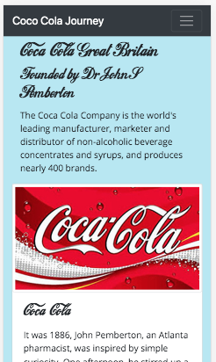

Figure 29: Testing the LOKICOLA.TTF fonts.

You should observe, if you comment out the font-family: cocaColaFont; when the Oswald fonts are also commented out, the fonts will default to whatever the Bootstrap default is, then uncomment the Oswald, and you will see the font change again. It’s worth getting this right, i.e. the fonts installed correctly, often when it does not show your font, you never notice when a new font is similar to a default font. Often, you have the URL path to your installed font wrong and never noticed, or you can’t see your font working, check the path.

Ok, so our fonts are installed, we styled the body, our drinks image text is using the Oswald fonts, etc. Take a moment to understand that this is because you have attached these styles to the HTML5 through the associated div tag ID selector, e.g. #main_text, which if you recall back on page 31 we created the id=”main_text” selector to allow us to manipulate the main text independent of the image drinks text in the three columns.

### Continue to build your custom.css file

Let’s continue to build your custom.css file, first create a rule to modify the body CSS so that we overwrite the Bootstrap 4 default #FFF background colour and adjust the padding to move the main content down from the nav-bar a bit, then we can get rid of the temporary <br> tags. Insert this CSS rule above the small device’s media screen break as indicated.

/* Extra small devices (portrait phones, less than 576px)

No media query since this is the default in Bootstrap

*/

body {

padding-top: 30px;

padding-bottom: 5px;

background-color: rgba(182, 231, 243, 1.0);

}

/* Some simple CSS rules for styling p, h1 to h6, etc. in the main content’s container */

p {

font-family: 'Open Sans', sans-serif;

}

h1, h2, h3, h4, h5, h6 {

/*font-family: 'Oswald', sans-serif;*/

font-family: cocaColaFont;

}

/* Small devices (landscape phones, 576px and up)

*/

@media (min-width: 576px) {... }

In general, it is very desirable to change the themes in Bootstrap to avoid your site looking like a Bootstrap site. Bootstrap offers a way to do this via node.js, npm that involves rebuilding their CSS files to create a custom CSS file. However, we will do it manually. The following site give a good overview on ‘[How to easily Add Custom CSS to Bootstrap with Examples](http://www.kodingmadesimple.com/2015/01/add-custom-css-to-bootstrap-examples.html).

You can adjust the actual pixel dimensions by looking at the result and iterating until you are satisfied. Play around with the padding-top and the background-color. What do you observe? First, the padding-top: 30px pushes the navbar down and obviously, the background-color changes the background colour.

The navbar being push down is not what we want in this case; we want the navbar to be fixed at the top. We need to wrap the main contents in a div with an id or class and adjust the margins or padding for the div. Modify the custom.css with the following code:

/* Extra small devices (portrait phones, less than 576px)

No media query since this is the default in Bootstrap

*/

body {

background-color: rgba(182, 231, 243, 1.0);

}

.main_contents {

margin-top: 10px;

margin-bottom: 10px;

}

You can now add this class to either the div with the container class. Alternatively, you can create another div with this new .main_contents class around the main contents, Figure 30.

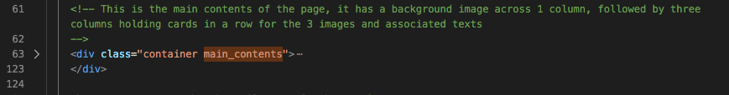

Figure 30: Insert a div and create a main_contents class to allow margins to be adjusted

You will see the main content now move down a tad to leave a decent visual gap, it is subjective of course, between the header and the main text (Coca Cola Great Britain) and the footer.

We already restyled the default h2, h3, and p tags for the drinks text above when we tested the font-family: cocaColaFont. In a similar way, we can also override the h and p tags for the #main_text and the .logo class, which we have yet to create.

Ok, let’s write some CSS rules to style the main_text:

#main_3d_image {

background-image: url(../assets/images/main_3D.jpg);

background-repeat: no-repeat;

background-size: cover;

/* The div block for the main_3d_image has no vertical size,

so we need a height to see the background image */

height: 200px;

}

#main_text {

float: left;

margin: 5%;

width: 90%;

display: block;

background-color: rgba(255,255,255,0.8);

padding: 10px;

border-radius: 5px;

}

#main_text h2 {

color: rgba(0,102,153,1);

font-size: 20px;

margin-top: 0px;

margin-bottom: 5px;

}

#main_text h3 {

font-size: 15px;

margin-top: 5px;

margin-bottom: 5px;

}

#main_text p {

font-size: 12px;

margin: 0px;

line-height: 1.2;

}

We leave you to do some background research on what each CSS rule does, and experimentation on what values to use for the mobile device. These values are reasonable for the ‘Extra small devices (portrait phones, less than 576px)’, i.e. for overwriting the default Bootstrap at this media breakpoint.

### Get used to using Chrome Developer Tools to examine your site

“[Chrome DevTools](https://developers.google.com/web/tools/chrome-devtools) is a set of web developer tools built directly into the [Google Chrome](https://www.google.com/chrome/) browser. DevTools can help you edit pages on-the-fly and diagnose problems quickly, which ultimately helps you build better websites, faster”.

But, if you set up Chrome Developer Tools like that shown in Figure 31 you can examine each of the HTML5 elements and check how the CSS is computed. For example, if you untick the Oswald font family it will default to whatever the Bootstrap font is being used, and they are very similar?

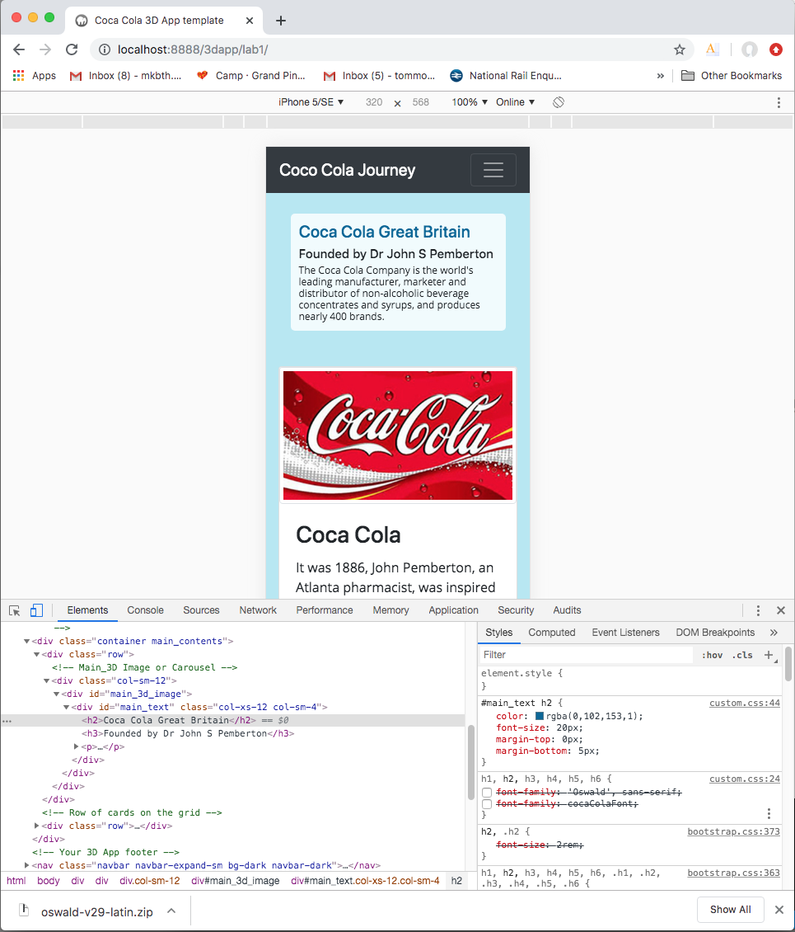

Figure 31: An initial CSS styling for the main_3d_image and main_text

If you scroll down the Style tab to the bottom, the little square diagram shows you the relationship between the position, margin, border, padding and actual size of the element, which in the case shown in Figure 32 is the <h3> Founded by Dr John S Pemberton </h3> subtitle. Have a play around and you should arrive at a reasonable set of CSS styling rules as indicated above, and don’t forget you can update these later.

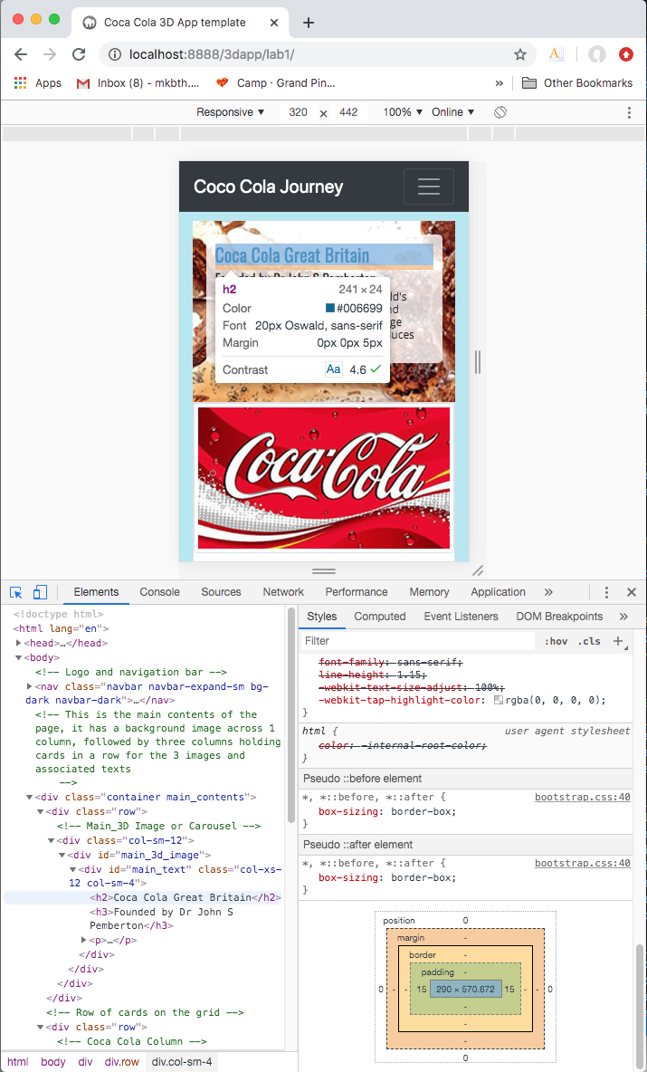

Figure 32: Examine the positioning, e.g. margin and padding relative to the element size

From our results, so far, we can see that the three cards in which the drinks images and associated texts need some margin at the top and bottom, select the first one in the Chrome Developer Tools and check the padding, margins, etc. and in particular select the .img-thumbnail class. Copy the Bootstrap .card class from the Chrome Inspect Tool Styles tab and put it in the mobile first breakpoint as before. You can then delete attributes you are not likely to change, and modify as follows:

.card {

border: 1px solid rgba(0,0,0,.125);

/* border-radius: .25rem;*/

margin-top: 10px;

margin-bottom: 10px;

background-color: rgba(182, 231, 243, 1.0);

}

You could, of course, just copied the above code. You will notice we now have the background image showing, do this by uncommenting it. We have made the background colour the same as the body colour, and we have left the card border 1 px just show where it is. Later for blending the card into the site better you can remove the 1px border value, i.e. set it to 0 px.

Your main contents for the mobile should now look something like that shown in Figure 33. We leave you to look up what each CSS rules for .card do.

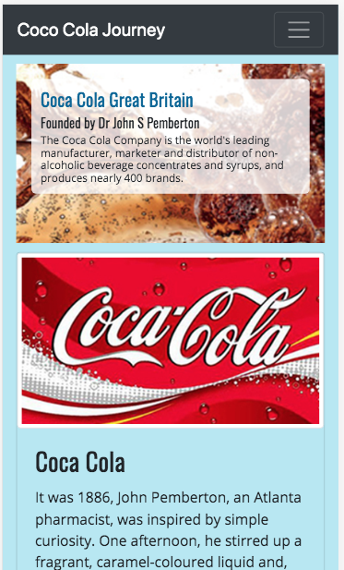

Figure 33: Main contents styled for the mobile media query break point

The CSS rules are largely done for the main contents for the mobile, i.e. the smallest screen size. However, currently we are defaulting to the Bootstrap .card class for the mobile, which is 16 px, maybe a bit large, so consider adjusting to 12 or 13 px. However, remember these values propagate up, so they will need adjusting for each of the larger screen sizes later. We can now move on to either create the CSS rules for styling the header and footer or modify these rules for the tablet and desktop main contents.

Let’s move on to styling the header, then the footer, and then modify the whole lot for the tablet and desktop.

## Create the CSS rules for the mobile header logo and navigation menu

We will start by designing the logo. At the moment, we have a temporary logo, which is simply the words: Coca Cola Journey.

### Style the logo

What we would like to do is use fonts to create a logo that is as close s possible to the coca cola logo indicated in Figure 34.



Figure 34: The Coca Cola logo

To develop this logo we simply need to wrap the text indicated in a div tag with a logo ID or class selector and use the h and p tags with their style changed inside the scope of the logo div tag; let’s use a .logo class in case we want to use the logo again on the same page.

So, go to your index.html file and replace the current logo:

<a class="navbar-brand" href="#">Coca Cola Journey </a>

With:

<div class="logo">

<a class="navbar-brand" href="#">

<h1>1</h1>

<h1>oca</h1>

<h2>Cola</h2>

<h3>Journey</h3>

<p>Refreshing the world, one story at a time</p>

</a>

</div>

This will allow us to write CSS rules that override the default h and p tags styles as follows:

/* CSS rule to style the mobile logo */

.logo {

margin-top: 3px;

}

.logo h1 {

font-family: cocaColaFont; /* You don't need to repeat this for each media query as it is propagated */

font-size: 31px;

margin: 0;

margin-top: -10px;

margin-bottom: -15px;

float: left;

padding-top: 0px;

padding-left: 0px;

padding-right: 2px;

}

.logo h2 {

font-family: cocaColaFont;

font-size: 31px;

margin-top: -6px;

margin-bottom: -15px;

padding-top: 0px;

padding-left: 0px;

padding-right: 3px;

float: left;

}

.logo h3 {

font-size: 18px;

margin-top: 0px;

margin-bottom: -5px;

padding-top: 0px;

padding-left: 0px;

float: left;

}

.logo p {

font-size: 7px; /* You may have to tweak this to get a good fit */

margin-top: 22px; /* You may have to tweak this to get a good fit */

margin-bottom: 0px;

padding-top: 0px;

padding-left: 3px;

}

The key things to take away from these CSS rules are that they are designed to manipulate the size of the 4 different fonts elements to the logo, float the logo left and position each text element relative to each other. You should note that these CSS rules will propagate up to the larger screen sizes, check it out before you change these rules for the tablet and desktop. For the larger screen sizes, we will eventually increase the height of the navbar and hence increase the size of the logo to match. In the meantime, you should now have a mobile styled logo looking like that shown in Figure 35.

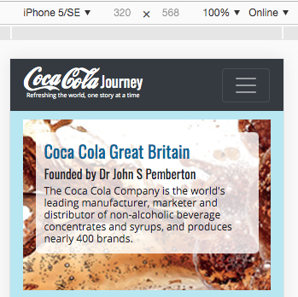

Figure 35: The lokicola.ttf based Coca Cola logo

That is somewhat different from the temporary logo we had before. Not perfect, we haven’t attempted the Trade Mark ™, for example, and the curl running under the Coca is below the line of the text. Also, we have defaults to whatever Bootstrap font is for the ‘Journey’ and ‘Refreshing …’ However, you get the picture, you can develop it some more.

We now need to set the background colour and text colours to better match the coca cola logo illustrated in Figure 34.

### Style the navbar

We will do this by styling the navbar, i.e. overriding the Bootstrap CSS. While we are at it, we will insert some other CSS rules to override other navbar features. This will allow us to play around with the navbar without needing to modify the bootstrap.css file. Here we will override the Bootstrap CSS rules by creating our own navbar-coca-cola class to replace the bg-dark navbar-dark classes.

HTML:

<!-- Logo and navigation bar -->

<nav class="navbar navbar-expand-sm navbar_coca_cola">

CSS:

/* New CSS rules to better position the navbar and increase its height, Bootstrap defaults tend to make your site look like a Bootstrap clone!

*/

/* CSS rule to overwrite the navbar background and border color — again, helps to stop your site looking like a Bootstrap clone!

*/

.navbar_coca_cola {

background-color: #760003; /* Set navbar background color */

/* border-color: yellow; Sets the navbar border color */

/* border-style: solid; */

border-width: 0px;

min-height: 70px;

}

/* CSS rule to overwrite the navbar-brand font color

*/

.navbar_coca_cola .navbar-brand {

color: rgb(245, 235, 235);

}

/* CSS rule to overwrite the navbar-brand font hover color

*/

.navbar_coca_cola .navbar-brand:hover {

color: green;

}

Again, you can look up what each CSS rule does, some you can eliminate in a final tidy up because they are there just to visualise the block element as they style, e.g. border-style solid and border-color yellow with border-width 1px will produce nothing unless you actually add a border-width greater than 0px. It is simply there to debug the relative position of the navbar to see if when you adjust the height it impacts on block elements below. On the other hand, the background-color has been ‘picked’ from the palette of colours in the Lab 1 images.

So, that’s the navbar and the navbar-brand re-styled from the Bootstrap defaults for mobile. Let’s have a play around with the dropdown navigation menu to finish off the header styling.

### Style the navigation menu

Here it may get a little bit more confusing because we are about to dump a pile of navigation menu CSS rules on you, and they aren’t perfect, could probably do with some tidying up. However, there is a Bootstrap 3 Tutorial and Part 11 is where it discusses [CSS modifications to the Navbar and Buttons](https://www.youtube.com/watch?v=7v2yC3GyDHU). Although, it doesn’t quite work for Bootstrap 4, the principle is the same. So, it’s worth a look.

We have created a new class .navbar_coca_cola from which we can access the sub-elements of the navbar menu:

/* NAVIGATION MENU

*/

/* CSS rules to overwrite the position of the Bootstrap menu. These are derived from the

Bootstrapbay Bootstrap Tutorial Part 11 — CSS Modifications to Navbar and Buttons shows how to do this using Bootstrap 3, the principle should be the same: <https://www.youtube.com/watch?v=7v2yC3GyDHU>

There is plenty more styling to do than indicated here, in mobile it still defaults to Bootstrap CSS on dropdown!

*/

.navbar_coca_cola .navbar-nav > li > a {

color: white;

}

/* CSS rule to overwrite the bootstrap.css text hover color on the navbar

*/

.navbar_coca_cola .navbar-nav > li > a:hover,

.navbar_coca_cola .navbar-nav > li > a:focus {

color: green;

}

.navbar_coca_cola .navbar-nav .nav-item {

margin-top: 0px;

}

/* CSS rule to overwrite the bootstrap.css rules for setting the active font color and background colour

*/

.navbar_coca_cola .navbar-nav .nav-item > .active,

.navbar_coca_cola .navbar-nav > .active > a:hover,

.navbar_coca_cola .navbar-nav > .active > a:focus {

color: #760003; /* Font color for active font */

background-color: #3399ff; /* Blue color for background */

}

/* A set of CSS rules to change the Bootstrap defaults for the menu link text color, hover, background, focus

*/

/* CSS rule to overwrite the bootstrap.css text hover color on the navbar

*/

.navbar_coca_cola .navbar-nav > li > a:hover,

.navbar_coca_cola .navbar-nav > li > a:focus {

color: green;

}

As before, you can do some research to investigate how these CSS rules work. But, in summary, you can see that we need to add the .navbar_coca_cola class to the <nav> tag, see Figure 36. We have removed the .bg-dark and .navbar-dark classes. Until we style the hamburger icon, in a minute, you won’t be able to see it. Note also that for the toggle between hamburger button are now targeting with an id= “navbarSupportedContent”, see Figure 36.

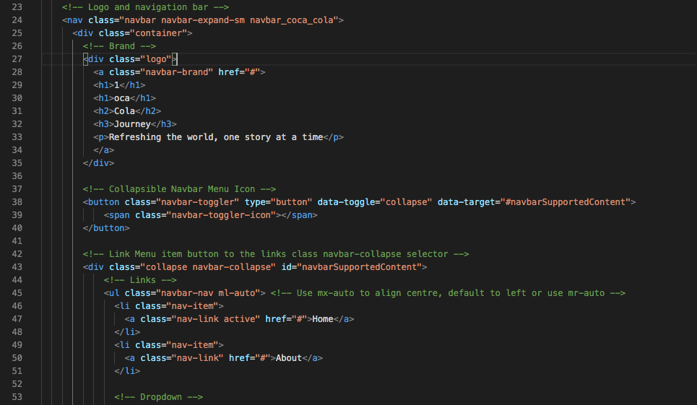

Figure 36: Modify the <nav> tag to add the .navbar_coca_cola class and add the navbarSupportedContent id for the menu icon

So, while we are here, let’s look at how we styled the hamburger menu button:

/* These next two CSS rules control the style of the icon bar */

.navbar_coca_cola .navbar-toggler {

border-color: white;

}

.navbar_coca_cola .navbar-toggler-icon {

background-image: url("data:image/svg+xml;charset=utf8,%3Csvg viewBox='0 0 32 32' xmlns='http://www.w3.org/2000/svg'%3E%3Cpath stroke='rgba(255, 255, 255, 1.0)' stroke-width='2' stroke-linecap='round' stroke-miterlimit='10' d='M4 8h24M4 16h24M4 24h24'/%3E%3C/svg%3E");

}

It is important to understand that in Bootstrap the .navbar-toggler-icon uses an image, but this image can change color by simply changing the: stroke='rgba(255, 255, 255, 1.0), color. Similarly, you can change the width of the stroke: stroke-width='2', I have just set this to 4. IMHO, I think this Bootstrap 4 method for creating a hamburger menu button is a retrograde step from the Bootstrap 3 method using the .icon-bar class. But, there you go, might look around for a better method.

### Style the navigation dropdown menu

Finally, we should also style the drop-down menu, but this is a bit more involved. The new classes are:

.dropdown

.dropdown-toggle

.dropdown-menu

.dropdown-item

You should be able to check out these classes in the bootstrap.css file or inspect them in Chrome’s Inspection Tool.

Tips to get going! Given we can easily examine the .bootstrap-menu class in either the bootsrap.css file or the Google Chrome Styles tab, see Figure 37, we can simply copy this class into our custom.css file and edit it by removing and attributes we didn’t want to change and changing the values of those that we do want to change. In this way, I have quite easily created override classes for the .dropdown-menu, .dropdown-item, and .dropdown-item:hover, see Figure 38. Yes, the colors are awful, this is just to demonstrate!

For example, Figure 37 shows that I have changed the background color, border-radius, font-size and text-align values simply by changing the values in the Styles tab for the bootstrap.css. So, we should be able to develop our own .dropdown-menu class to override the Bootstrap version for those attributes of interest. I will leave you to complete this, or simply leave the default dropdown styling as it is. However, you will probably want to do this for the assignment though.

Ok, here’s our suggested CSS:

/* Let's style the dropdown menu

*/

.dropdown-menu {

text-align: -webkit-left;

background-color: #b6e7f3;

margin-top: 20px; /* Experiment to move the dropdown menu down */

}

.dropdown-menu .dropdown-item {

color: #eb0025;

}

.dropdown-menu .dropdown-item:hover {

color: #030303;

background-color: #e98074;

}

There is more styling to do, for example, the hamburger menu still has the default blue border when activated — easily fixed by creating a CSS rule to not display the outline:

.navbar_coca_cola .navbar-toggler {

outline: none !important;

}

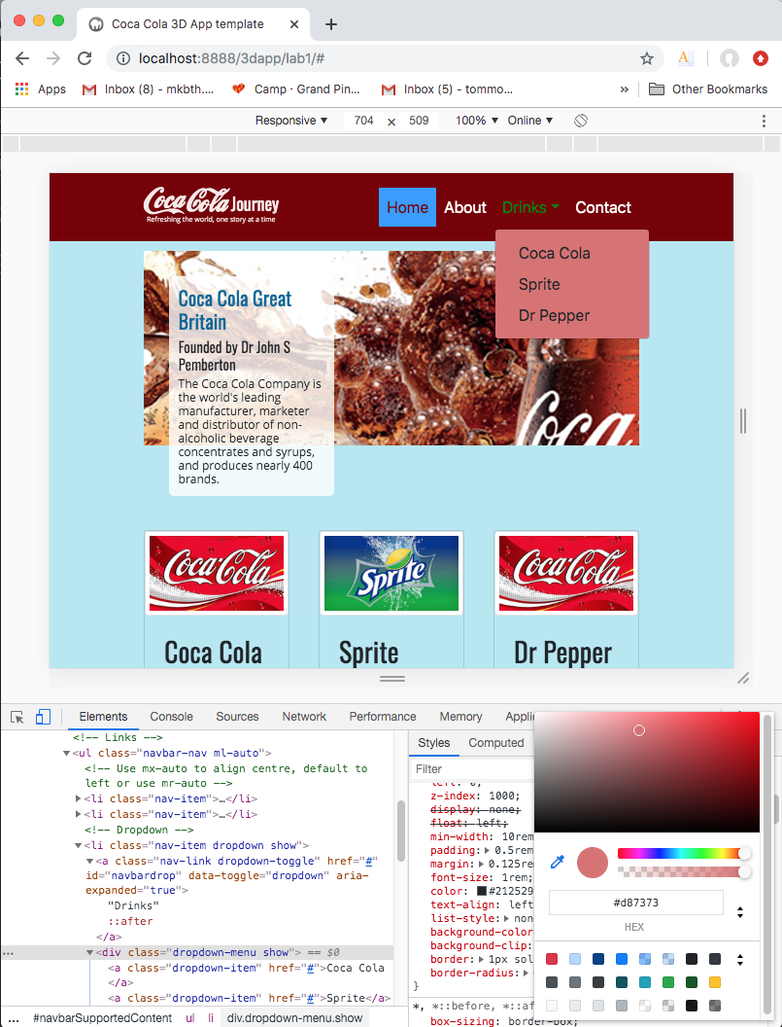

Figure 37: Change some values in the Chrome Inspection Tool for the .dropdown-menu class

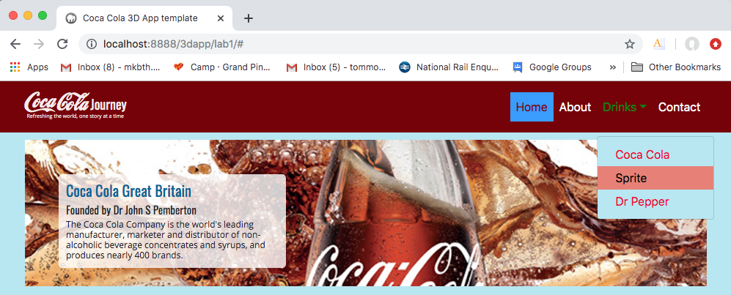

Figure 38: Overriding the .dropdown class with some awful colors!

Obviously, we need to provide a set of background images, one for each of the media break points. We’ll do this tidying up later, first let’s style the footer.

## Create the CSS rules for the footer

So, let’s style the footer navbar, there is not much to do here.

### Style the footer and its contents

I notice when we originally created the footer above, we used a <div>, we could use the <nav> tag as we did with the header. navbar like we did in Figure 17. Add a .footer class (and I strongly suspect that Bootstrap has a .footer class, so we will end up overriding Bootstrap attributes here) to allow changing of the Bootstrap background colour, etc. by removing the .bg-dark and .navbar-dark classes. You can see that we have also introduced two more classes, the .copyright and .socila classes. I did this because, I noticed both element did not line up nicely. The .float-left class seems to treat text font different from the .float-right treats fontawesome fonts? So, this allows us to adjust the padding around these elements. Bootstrap 4 has vertical alignment classes that may also work.

Update the code you wrote in Figure 17 to that shown in Figure 39.

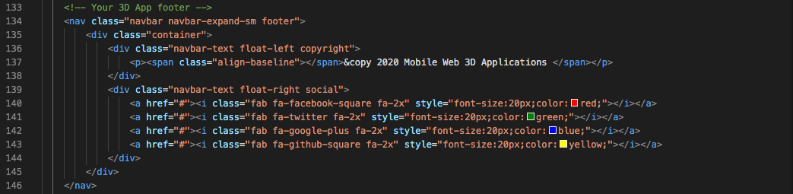

Figure 39: The new footer code

Now you will overwrite the Bootstrap default CSS for the footer min-height, and style the contents.

/* CSS rule to style the footer */

.footer {

color: #030303;

background-color: #760003; /* Set navbar footer background color same as header */

height: 50px;

}

.navbar-text > a {

font-size: 10px;

}

.navbar-text > p {

color: rgb(255, 255, 255);

font-size: 14px;

text-decoration: none;

}

.copyright {

padding-top: 8px;

}

.social {

padding-top: 0px;

}

If you want to change the color of the Fontawesome icons, I believe the Fontawesome docs recommend doing this in line with the style tag, see Figure 39. However, you might want to include such style changes in your css file.

That’s about it, you have completed most of the basic CSS rules for the mobile media break xs (Extra Small); you should have something like that shown in Figure 40.

A couple of extra things before we move on; consider whether you want to use the .container class or the .container-fluid class. I notice that both the .container class and .container-fluid class in Bootstrap 4 appears to interfere with the hamburger position as you click it — the hamburger menu button jumps up and settles down again, weird! This is reported in the forums, but I can’t find a fix (maybe it is an ugly feature).

Also, I notice with the .container-fluid class that the header moves off screen when you scroll. You should be able to set a class to fix this to the top. It is easy, just use the .sticky-top class if you want this feature:

<nav class="navbar sticky-top navbar-expand-sm navbar_coca_cola">

Ok, there are going to be lots of other tidy up bits that need doing, so we’ll do that at the end.

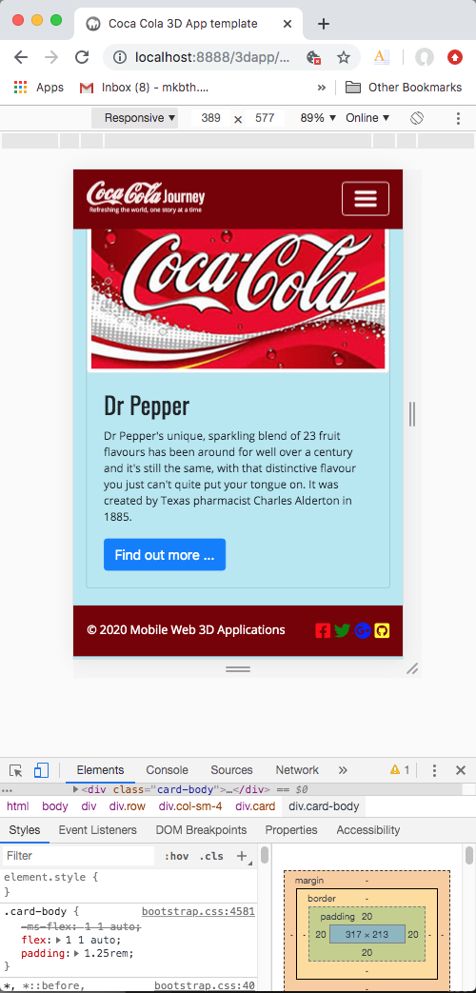

Figure 40: The nearly finished mobile xl version of Lab 1 results

## Create the CSS rules for the other screen break points

All you have to do now is copy those CSS rules, whose parameters need to be adjusted for the larger screen break points, to the appropriate media queries in your custom.css file. I’ll leave you to do that on your own, but just as an example, while the footer is fresh in your mind, let’s imagine that for the tablet you want to change the colour scheme of the footer, make the height a bit larger, change the font size, and so on. You just need to copy over those rules as follows, delete the attributes you are not changing because these are propagated anyway, and change only those parameters you want to change. And, remember these changes are propagated onto the next screen sizes as we go up from mobile to desktop, etc.

/* Small devices (landscape phones, 576px and up)

*/

@media (min-width: 576px) {

/* CSS rule to style the footer */

.footer {

background-color: #257600;

height: 60px;

}

.navbar-text > a {

font-size: 10px;

}

.navbar-text > p {

color: rgb(228, 75, 15);

font-size: 18px;

}

.copyright {

padding-top: 20px;

}

.social {

padding-top: 7px;

}

}

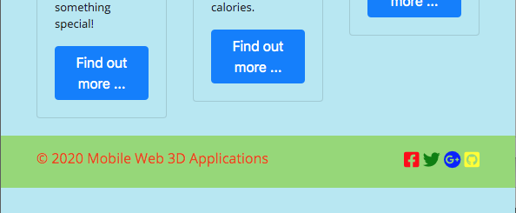

Figure 41: The footer style changed for the Small devices (landscape phones, 576px and up)

Ok, so you should be able to finish off the styling for all the media breakpoints however you like, while keeping to the overall brand.

Tip, you will need to create a range of main_3D.jpg image resolutions to scale the background main_3D div tag with for all media screen breakpoints. For example, you could prepare, in Photoshop, main_3D.jpg images for x res 290, 400, 538, 768, 970, and 1400. You might like to prepare your main_3D.jpg images for the actual Bootstrap 4 media breakpoints.

To be clear, you will need a main_3D.jpg image that will look ok on screens less than 576 px, one for between 576 px and 768 px, and so on. This should allow for smooth scaling between a mobile retina display and a large high res desktop. Tip, you can also choose the most appropriate main_3D.jpg image as you visualise the screen breaks point when you scale the browser up and down.

For the tablet (iPad Pro using the Chrome Inspect device toolbar), I have styled as indicated in Figure 42 — you can check out the **Live Feedback Site** to look at the CSS code if you are not sure. The CSS styling indicated in Figure 42 is adequate for most desktops, i.e. the desktop layout is the same as the high resolution tablet layout. This is the CSS styling for the last media query, and will work up to my 1400-pixel wide main_3D image, anymore and I would have to prepare a larger image.

Figure 43 indicates the CSS styling for the mobile, e.g. an iPhone. We haven’t had to create any CSS rules to change the .card class text and title because the .card class is fluid. But, for any device smaller that the iPhone 4, we would need to use a smaller main_3D image and adjust the font sizes for the main_text.

Figure 43 shows the in-between screen break CSS styles. Yes, the colours are fanciful, and merely to illustrate!

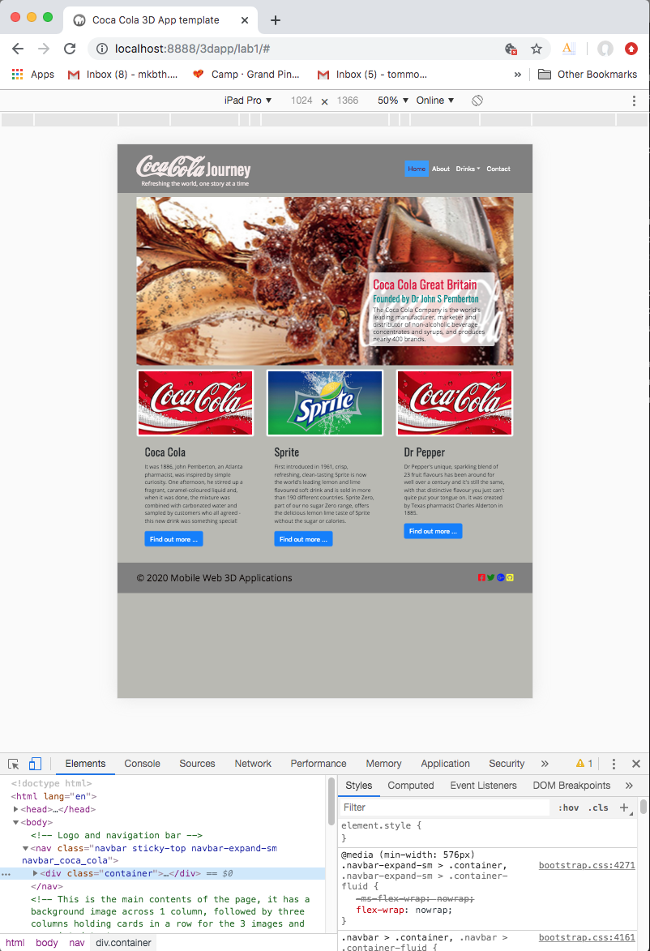

Figure 42: Lab 1 result for iPad Pro with some CSS styles

|  |  |
| --- | --- |
|  |  |
| iPhone 8 | iPad Mini |

Figure 43: CSS styling for the mobile, in this case tested with the iPhone 8 and iPad Mini

|  |  |
| --- | --- |
|  |  |
| @media (min-width: 768px) | @media (min-width: 992px) |

Figure 44: Lab 1 result for the in between screen breaks

In Lab 4 you can explore some more Bootstrap features to add to this template such as a Jumbotron Light Box made from a Modal, Gallery made from a Carousel maybe, etc. In Lab 3 we will exploit selected Bootstrap components in which to embed X3D code needed to allow you to display your 3D models in your 3D App. You will create the some relatively simple 3D models in Lab 2 and convert to a Web3D Format (X3D) in Lab 3.

## Tidy up your CSS

So, you should now have your basic Lab 1 result for mobile (xs), desktop (xl) and other screen sizes in between completed. There may be elements you need to tidy up. I would suggest you spend some time playing with setting CSS values for all the different screen breaks, be inventive with CSS. Anyway, that’s a background activity, the more practice at building your own templates the better.

One of the things you might like to focus on is how to change fontawesome icon size and colours for each media screen break actually in CSS. In which case, you might like to [install the fontawesome](https://fontawesome.com/how-to-use/on-the-web/setup/hosting-font-awesome-yourself) fonts rather than use the CDN, see using web fonts with CSS. Here is my slight rejigged footer code and associated CSS. The CSS is taken form the al.css file and placed in the media screed break of your custom.css to override allowing individual control over each icon. Clearly, you can see that all you have to do is repeat for each media screen breaks and adjust as required.

HTML5:

<!-- Your 3D App footer -->

<nav class="navbar navbar-expand-sm footer">

<div class="container">

<div class="navbar-text float-left copyright">

<p><span class="align-baseline"></span>&copy 2020 Mobile Web 3D Applications </span></p>

</div>

<div class="navbar-text social">

<a href="#"><i class="fab fa-github-square fa-2x fa-pull-right"></i></a>

<a href="#"><i class="fab fa-google-plus-square fa-2x fa-pull-right"></i></a>

<a href="#"><i class="fab fa-twitter-square fa-2x fa-pull-right"></i></a>

<a href="#"><i class="fab fa-facebook-square fa-2x fa-pull-right"></i></a>

</div>

</div>

</nav>

CSS:

.social {

padding-top: 0px;

width: 30%;

}

.fa-twitter-square:before {

content: "\f081";

color: green;

font-size: 1em;

}

.fa-github-square:before {

content: "\f092";

color: yellow;

font-size: 1em;

}

.fa-google-plus-square:before {

content: "\f0d4";

color: blue;

font-size: 1em;

}

.fa-facebook-square:before {

content: "\f082";

color: red;

font-size: 1em;

}

Our final results can be found on the **Live Feedback Site**.

**Reminder**, in your assignments you are not allowed to download and use a ready built template!

# Part 5 Publish your website — Lab 1

Part 5 of this lab 1 tutorial shows you how to set up a remote site, i.e. how to publish on the University ITS web server. We already discussed this in Part 1 to some extent, so most of this should be a reminder. A remote site is usually a web server on a remote computer that holds copies of your local files. Users access the remote site when they view your pages in a browser.

If you are working from home, you will need to remotely upload your site the ITS Webserver, see Appendix K. However, if you are logged on to a University lab machine, uploading to your ITS Web Server space is as simple as copying over your site from your Home Share/ drive to your /public_html/ directory, see Part 1 of this tutorial**. Don’t forget, you need to have registered for your ITS Web Space, you cannot simply create a public_html folder!**

For example, suppose you have been developing in your Home Share/public_html/3dapp/lab1/ folder, then technically your site is already online at:

http://users.sussex.ac.uk/~username/3dapp/lab1/

However, this is really a development site where you are storing your local files, but it obviously doubles as a test site too. Clearly to publish your site, for example an assignment, all you have to do is create a publishing assignment folder and copy your site to it:

Home Share/public_html/3dapp/assignment

This would then be accessed like so:

http://users.sussex.ac.uk/~username/3dapp/assignment/index.php

If you want us to check out your Lab 1 site, or for that matter Lab 3, 4, 5, …, remotely you simply need to make sure it is live on the ITS web server and we can remote in. You would need to send us the URL as indicated (with your username), and with this we can look at:

* The source code — use Chrome Developer Tool
* And, knowing your username we can remotely use SFTP to read your site. We will only have read permission and download, but we can do a certain amount of helping you to debug remotely in this way — this is for an emergency, of course. We expect you to bring most issues to the Lab session, as obviously, we cannot do this for dozens of students 5 minutes before hand in!

# Part 6: Set up Git and GitHub with Visual Studio Code

You need to get into the habit of using a version control system (VCS) to manage your code. There are several open source VCS around, for example check out this [15 best version Control Software (Source Code management Tools)](https://www.softwaretestinghelp.com/version-control-software/) discussion.

We already mention that we are using Visual Studio Code to store your site on GitHub. Appendix L gives some more details.

# Appendices

## Appendix A — Getting Started

### Set up your coding environment

You will need a modern open source text editor to edit your markup and code, we will use [Visual Studio Code](https://code.visualstudio.com/) in this tutorial, but you can use other code editors such as [Sublime Text](https://www.sublimetext.com/) or [Brackets](http://brackets.io/), and [Notepad++](https://notepad-plus-plus.org/) which are already installed on the Informatics lab machines. Further, if you are already familiar with Dreamweaver CC you could use this as your code editor too; with the advantage that Dreamweaver CC has a file manager and SFTP built in, as well as a design view.

### Required Libraries

You will also use the [Bootstrap 4](http://getbootstrap.com/) (an open source toolkit for developing with HTML, CSS, and JS) extensively, either installed or linked into your site. You will be using JavaScript, JQuery and PHP.

### Integrating with GitHub

In all our tutorials, we are using Visual Studio Code because it integrates with GitHub quite well. However, other coding environments also integrate with GitHub, such as Dreamweaver CC. You are likely to find several coding environments that link with GitHub on the Informatics teaching labs. However, you may decide it is better to use [Visual Studio Code](https://code.visualstudio.com/) as your code editor because all the tutorials do so. Further, you may want to **optionally** check out any of many YouTube videos, which show you how to set up your [GitHub account in Visual Studio Code](https://visualstudio.github.com/). This also implies that you need to get yourself a [GitHub](https://github.com/) account, if you haven’t already got one.

### Prerequisite knowledge

This tutorial requires no previous knowledge of a full web development stack — you will **learn by doing** in the lab (or at home) using the Canvas learning materials. As such, we do require you to be inquisitive and look stuff up online. we will provide links where appropriate to go and find out information.

### Live Feedback Site

This laboratory tutorial gives you, in advance, a completed version of the end result, as such you can easily see all the HTML5 and CSS3 needed to create a simple responsive mobile first web page based on a grid layout using Bootstrap, **but** you should also do some extra background reading and experimentation. The reason for showing you the end result is so that you can use it to help debug your work.

Lab 1 tutorial result are located at the **Live Feedback Site**, but for the Bootstrap version navigate to the Lab 1 Bootstrap site, here you will find versions completed in Dreamweaver way back in 2015, Bootstrap 3 versions completed in 2016 and 2017, and a Bootstrap 4 completed in 2018 — you can use Chrome’s Developer Tools to analyse this Lab 1 site for learning purposes, e.g. to check out where you might have gone wrong, etc. The Bootstrap 4 2019 version will go live soon.

However, please, don’t simply copy a completed version, make sure you understand the principles and can build your own version! The approach you take will depend on any previous HTML5 and CSS3 knowledge you may have. We are not compelling you to use Bootstrap, if you already have another favoured front end framework with a fluid grid, then use that, but you should produce a result **as close** to the later Bootstrap 4, e.g. [BS4 2018](http://users.sussex.ac.uk/~martinwh/3dapp/3D_Apps_2018/lab1/bootstrap2018/) or BS4 2019 ,fluid grid version as you can — it should not be based on an existing template.

Notice that I said, ‘**as close**’ to the Bootstrap 4 fluid grid version as you can, it doesn’t have to be exactly the same, it can be improved and there are probably many features in Bootstrap that allow a more efficient version to be created. However, if you start off straight away by developing your own layout it might make it a bit more difficult for me to initially help you debug it if it goes wrong.

Later on, i.e. for the assignment, you can continue to use Bootstrap, or any front-end framework you like for your 3D App, but again it has to be your own work. So, if I detect, for example, in your assignment that you have simply utilized to a very large degree an **existing front-end framework template or theme**, I can’t give you any marks for that! This means that you are better off not using an existing Bootstrap (or any other framework’s) template or theme already created by someone else. You should create your own layout according to the comp given (or similar) — I’m not that pedantic, the key thing is that you pick up necessary CSS and HTML skills —enough to build your assignment for this module.

The following exact tutorial instructions for Lab 1 are not critical as such, but you should be in a position to publish around Week 6 a basic responsive mobile web 3D app (basic 3D app). For this basic 3D App, you can develop a completely new fluid grid layout, or you can refine/modify your Lab 1 initial layout (code reuse). The key thing is that it has to be developed by you!

If you are **fairly confident and keen to get on without reading ton’s** of text, then a good way to do Lab 1 is to simply follow a good set of video tutorials, and there are many online. For example, I think the Bootstrap Bay Bootstrap video tutorials are quite reasonable and they show you how to develop a responsive site, but you have to fill in the gaps. The tutorial is comprised of 16 YouTube videos located at:

* <https://www.youtube.com/user/bootstrapbayofficial>

However, note these videos use Bootstrap version 3, and in this tutorial, I have moved onto version 4 — you might be able to find equally useful YouTube tutorials based on Bootstrap 4.

Video tutorials 1 to 11 will enable you to create a Bootstrap version of Lab 1 relatively easily:

* [Bootstrap 4 — 2018 Lab 1 results](http://users.sussex.ac.uk/~martinwh/3dapp/3D_Apps_2018/lab1/bootstrap2018/)

A word of warning, you should be prepared to look up online any detail on code snippets that you are not familiar with. It is often useful to use sites like w3schools to try out snippets of code beforehand.

## Appendix B — Some Technical Details

### Different technical approaches

There are different ways we could develop a simple responsive and mobile first web 3D application (3D App). For example, given we first need a fluid grid layout, we could consider at least three approaches to creating a 3D App:

1. **We could use a responsive and/or mobile first web design approach** that utilizes a fluid grid layout for HTML5. There are many frameworks available that aid in responsive web design, and they usually rely on a fluid grid layout where element or block widths such as columns are expressed as a percentage of the page width. For example, older versions of Dreamweaver (CS6) had its own version of a fluid grid layout scheme based on JavaScript and CSS3 — for historical purposes we still have a Lab 1 [DW](http://users.sussex.ac.uk/~martinwh/3dapp/3D_Apps_2018/lab1/dreamweaver2016/) version available on the **Live Feedback Site**. Dreamweaver CC now utilises Bootstrap, I think? If you Google ‘responsive fluid grid’ you will find many frameworks adopt this approach: [W3.CSS](http://www.w3schools.com/w3css/) has its [W3.CSS Grid](http://www.w3schools.com/w3css/w3css_grid.asp), [Bootstrap](http://getbootstrap.com/) and [Foundation](http://foundation.zurb.com/) to name a few. Alternatively, frameworks like [AngulaJS](https://angularjs.org/) can be used to create responsive web design, see [Google slides and demos](https://docs.google.com/presentation/d/10qoU_mIhRLDmq-ej5xd9-DXR09DUeIPMtUp0-Il6c_o/edit#slide=id.p). The key thing is that responsive and mobile first web design approaches allows you to create your web app and deliver it on different devices, e.g. browser, tablet and smartphone, where elements (sections, images, etc.) of the page scale and rearrange (due to the fluid grid layout) to the device screen size. Other key elements to the implementation of a responsive web application are the use of media queries and scaling of images and fonts, etc.
2. If you know that you only want to target a specific mobile device, e.g. an Android smartphone or iPhone, you could use a particular development methodology to optimally target that device. For example, you might use [Android Studio](https://developer.android.com/studio/index.html). If your app needs to run fast, or access the device’s hardware, and so on, this may be the best approach. **This is often referred to as native development**.
3. There are also other abstraction frameworks, for want of a better term, that allow you to design at a higher (HTML, CSS and JavaScript) level. For example, [PhoneGap](http://phonegap.com/), and [Apache Cordova](https://cordova.apache.org/) are open source frameworks (also integrated with Dreamweaver CC), which allows you to create mobile apps using standard web technologies: HTML, CSS, and JavaScript. Dreamweaver CC also offers app developer layouts and templates to aid in development of specific device apps. For example, they have a JQuery Mobile template to get started. There are many other frameworks such as [Sencha](https://www.sencha.com/) that can help you to deploy HTML5 applications on desktops, tablets and smartphones. **This is often referred to as a hybrid approach.**

Approach 2 and 3 are beyond the scope of this Mobile Web 3D Application module, so we will use approach 1, and in this tutorial, we will utilize a good text editor, i.e. [Visual Studio Code](https://code.visualstudio.com/) to input code and markup with Bootstrap’s fluid grid layout.

## Appendix C — Setting up your project files

### Local and remote files

So, let’s get started, a web *site* generally consists of two parts:

1. A collection of files on a local computer (the local site). For example, this could be your site files on your own laptop, or your University Home Share / drive on the Lab machines
2. And, a location on a remote web server where you upload files when you're ready to make them publicly available (the remote site). The remote server could be provided by your ISP (Internet Service Provider), but in the case of this module, we will be using the University Web Server.

For this tutorial document as you move forward, I assume that you will use Visual Studio Code, which has a built-in file manager to manage the files for your site, but you may be using some other code editor and your local file system to manage your files. Normally, you would create a website by creating and editing pages on your local drive — you should all know your local drive details provided by the School of Engineering and Informatics. You would then upload copies of those pages to a remote web server — in this case, your public_html location on the ITS web server — for viewing on the web.

Your first step will be to set up a local site and a remote site (ITS Web Space) that you will need to keep synchronised. This effectively mean that we need to set up what is commonly referred to as a **local folder** structure and a **remote folder** structure.

* **Local folder**: Set up a folder on your local drive, e.g. your lab Home Share drive or somewhere on your laptop, for example in my case I tend to use Dropbox. Call this local folder 3dapp, or whatever you like that makes sense. Locate it somewhere sensible, e.g. as I already said, your Home Share drive, or Dropbox … your PC documents folder, wherever. Another useful place for the Local Folder (if you always do your development work in the School labs) is to create a development folder off your public_html folder for, e.g. /public_html/3dapp/labs/lab1. A good reason for at least keeping a copy of your local folder here is that it is actually live on the ITS web server — this means you can test your work immediately online. And, that also means that I can actually see your result online and I can access this space remotely to help debug if necessary.
* **Remote folder**: In your case, eventually for your assignment, you will have to submit online to your /public_html/ folder, i.e. your Sussex ITS personal web space. As such, it is a good idea to get used to using this ITS space. For example, you should get used to organising your files on the ITS server something like: /public_html/3dapp/labs/lab1. You can use something similar for lab 2, lab3, and so on. Then for your assignment hand-in you would use /public_html/3dapp/assignment
* Note that I have already specified exactly this path as the one I want you to use for your assignment because I run a shell script that crawls this location hunting for the date and time of your last file submitted. Further, I need to know exactly your assignment URL path; otherwise I can’t mark your work!

During the course of this module you will be focusing on creating the front end (view), business logic (control) and back end data store (model) using a MVC (model, view, controller) design pattern for your 3D App that exploits a full web development stack: HTML5, CSS3, JavaScript (JQuery), AJAX and PHP. Therefore, you will need access to a PHP environment set up in your public_html space on the ITS web server — this is auto magically set up for you when you apply for your Sussex ITS web space, if you haven’t already got this check out: <https://www.sussex.ac.uk/its/webspace/> and follow the steps provided.

This further implies that you may need to set up a local host on your home PC or laptop, particularly if you want to work from home — of course, if you do all your work in the departmental labs, then you won’t need a localhost. However, I recommend setting up [MAMP](https://www.mamp.info/en/), which is available for both Mac and PC. There are others, e.g. [XAMPP](https://www.apachefriends.org/index.html), [WampServer](http://www.wampserver.com/en/), …, but I will be using MAMP. Those of you using a Mac might not know that [Macs also comes with a built-in web server](https://discussions.apple.com/docs/DOC-3083), but you have to set it up, and it is slightly different for each Mac OS — I haven’t bothered with this for quite a while as I prefer MAMP.

Your first step will be to set up your local site so you can begin building your initial web pages right away.

### Keeping track of your sites

In Visual Studio Code, Brackets, Dreamweaver CC, and probably other decent code editors, you can set up a site to organize (on your local computer, Dropbox, …) all the documents associated with your website. Depending on the code editor you choose to use, it may let you track and maintain links, manage files, share files, etc. In the case of Dreamweaver CC, it also lets you transfer your site files to a web server using a built-in SFTP client. In the case of this tutorial, using Visual Studio Code, you can edit and manage your files, store them in a GitHub repository, and you can also use a built-in command line tool. On the other hand, if you want to keep it very simple and use, for example, Notepad++, then for **site management** you would use your PC file system, and some common sense to manage the files for your site.

### Remote update for your site

To transfer files to the remote web server, you will need to use a secure file transfer protocol (SFTP) client such as FileZilla, CyberDuck, the built-in Dreamweaver SFTP client, or simply dump your working files on a USB stick and import it onto your Home Share /public_html directory.

In some circumstances, you might have more than one remote folder. For example, if you work in a team environment, all members of the team might upload their files to a common testing server before they are deployed on the live website. Also, it’s normal to set up a testing server when developing websites that use a server-side technology, such as PHP.

A typical setup for you if you decided to only develop your 3D App in the lab might be:

* **Local Site**: Home Share /3dapp/labs/lab1
  + - You would not need a localhost for testing here, because you would simply copy your site to the Testing Site.
* **Testing Site**: Home Share /public_html/3dapp/labs/lab1
  + - This is effectively live, so for example, if this was my public_html web space I could access (or test it) using: users.sussex.ac.uk/~martinwh/3dapp/labs/lab1/ and assuming I had an index.html or index.php file at this location it would be rendered in a web browser.
* **Remote Site**: Home Share /public_html/3dapp/assignment
  + - Same as for the testing site, this is obviously live, and accessed as such: users.sussex.ac.uk/~martinwh/3dapp/assignment/

Clearly, both the testing site and the remote site are live, i.e. they are on the University Web Server.

**Note:** In general, the root folder of your site is normally the main or top-level folder for your website. It usually corresponds to a folder called public_html, www, or www root on your remote server. For example, if you have a website at www.3dapp.com, and have a file called index.php in the root folder, its URL is:

* http://www.3dapp.com/index.php

So, to be clear, if you have chosen Home Share /3dapp/lab1, where Home Share / is your *pathvariable* for your **Local Site**, and if you then use Home Share /public_html/3dapp/lab1 as your **Remote Site** or **Testing Site** for Lab 1, then to go live, all you need to do is copy your local site to your remote site.

In this case, you will be able to access your Lab 1 result from:

* http://users.sussex.ac.uk/~username/3dapp/lab1/index.html

Where username is obviously your particular Sussex username.

Similarly, for this **Mobile Web 3D Application** module, when your **Mobile Web 3D Application** is finished (e.g. your **final assignment**) it will be accessed from:

* http://users.sussex.ac.uk/~username/3dapp/assignment/index.php

You can see that your specific public_html directory maps to users.sussex.ac.uk/~username, while your web site has to have an index.html (or index.php) to set up the server environment. That’s the way ITS have done it.

## Appendix D — Best practices for naming files and folders in a website

A typical website contains a large number of files and folders. For ease of maintenance, it’s important to organize them logically. Create separate, appropriately named folders for images, videos, style sheets, and external JavaScript files. Also keep the following points in mind:

* File and folder names in websites should never contain spaces or any of the following characters: /\?%*:|”<>.
* Although other special characters are permitted, it’s generally a good idea to use only alphanumeric characters, hyphens, and underscores.
* Most file and folder names end up as part of a web page’s URL, so keep them short, but meaningful. Long URLs are difficult for users to remember and type into browsers on a mobile device.
* The vast majority of websites are hosted on Unix or Linux servers, which are case-sensitive. Using all lowercase letters for file and folder names avoids problems with files not being found.

## Appendix E — Rationale for fluid grid

With today’s use of many different mobile device form factors across laptops, tablets and smartphones it has become increasingly necessary to develop online contents for multiple screen sizes. Sites have to be designed that adapt to a variety of device resolutions to use the screen real-estate effectively. Previously, we had to hand code media queries to solve this problem, which was very time consuming. But now, we have the advantage of being able to exploit a variety of, so called, fluid grid technologies with CSS3 media queries.

For this tutorial, our fluid grid layout will exploit [Bootstrap 4](http://getbootstrap.com/), which is, and I quote “the most popular HTML, CSS and JS framework for developing responsive, mobile first projects on the web”, or so they say! If you click on the previous link, you will see that you can download the Bootstrap libraries, currently version v4.3 at the time of writing.

So, you need to be careful about which versions of Bootstrap you use. You may come across code snippets that you want to adapt that only work with previous versions of Bootstrap. Indeed, in 2017 we tried to move to Bootstrap v4.0 from v3.0, but it wasn’t stable enough. Instead, we had to wait a year and migrated to Bootstrap v4.0 in 2018 — Bootstrap 4.0 is stable enough; and we haven’t come across any Bootstrap 4.3 issue yet!.

In situations like this, you may have to declare earlier versions as well if you wish to use some ‘older’ functionality no longer supported in later Bootstrap versions.

Now, it is highly likely that you will hunt around the Internet for open source code snippets with which to build your larger applications, just remember to cite them.

## Appendix F — Setting up your Bootstrap template

Make sure you have a read of the Bootstrap Getting started page, the template provided uses the Bootstrap CDN rather than the download you have installed in Part 2 of this tutorial. You can continue to use the Bootstrap CDN version, or the downloaded version. Up to you, but if you use the downloaded version you will need to change the link and script paths to your installed versions, as shown in this code:

<!doctype html>

<html lang="en">

<head>

<!-- Required meta tags -->

<meta charset="utf-8">

<meta name="viewport" content="width=device-width, initial-scale=1, shrink-to-fit=no">

<!-- Bootstrap CSS -->

<link rel="stylesheet" href="css/bootstrap.css">

<title>Hello, world!</title>

</head>

<body>

<h1>Hello, world!</h1>

<!-- Optional JavaScript -->

<!-- jQuery first, then Popper.js, then Bootstrap JS -->

<script src="js/jquery-3.4.1.js"></script>

<script src="js/popper.min.js"></script>

<script src="js/bootstrap.js"></script>

</body>

</html>

Looking at this code, you will have noticed that Bootstrap requires jQuery and Popper along with its own plugins to function correctly. If you decide to download the JQuery and Popper libraries and install them, then you can see which versions you need from the CDN path.

Having said that, I just had a look at the Popper.js site, and noticed that the installation instructions suggest several ways to install Popper, e.g. via a package manager (npm, yarn, …) or you can get it unpackaged (unpkg). To keep things relatively simple you can just grab the unpackaged version and copy it to a popper.js file, and while you are at it go to the CDN site and grab the popper.min.js code too and create a popper.min.js file. For Lab 1 we probably don’t need to use any of the popper functionality, but obviously Bootstrap needs it in general so we have it now.

Note, “a popper is an element on the screen which "pops out" from the natural flow of your application. Common examples of poppers are tooltips, popovers and drop-downs”[3]. One way to test how much this Lab 1 depends on the popper.js library will be to comment out the popper library when we create a drop-down, for example. If the dropdown stops working … we know we need it! There are reports on various forums that people are having headaches with installing popper, etc. If your installed version doesn’t seem to work, use the CDN.

Even if you decide to use the JQuery CDN, head on over to JQuery and download their libraries and put them in the ‘js’ folder — you may decide to use them later. At the time of writing, and according to the current CDN versions given you will need jquery-3.4.1.js. You could also rob up the libraries from the **Live Feedback Site**.

We should probably test this set up to make sure it all works ok, but we can effectively do that by using use Lab 1 as the testing set up for our libraries, etc. and adjust the libraries if needed as we go. That is, if our installed versions don’t work in some way, just use the CDN versions.

Incidentally, the *integrity* attribute on the CDN versions is effectively a cryptographic hash value to allow checking that the accessed library (CDN versions) has not been interfered with, and the *crossorigin* ([Cross-origin Resource Sharing](https://developer.mozilla.org/en-US/docs/Web/HTTP/CORS)) attribute is a mechanism to allow access to servers on a different domain.

You will see from Figure 6, and the code above, that we have settled for installing the libraries rather than using the CDNs, made some space for more libraries, if needed, stuck a title in, added some simple content ‘Hello World’, just to check it, and emphasize that the JavaScript files usually go towards the bottom of the HTML5 <body> tag.

This is to make sure that the DOM has loaded first before any JS functions are executed. However, later on you will use the [jQuery $(document).ready()](https://learn.jquery.com/using-jquery-core/document-ready/) function to wrap up your JS functions and stick them in a file, which does not execute until the DOM has completed.

## Appendix G — Create a fluid grid page with Bootstrap

Bootstrap’s grid system allows up to 12 columns across the web page, which can be grouped into a wider column, e.g. 2, 4, 6, 12, etc. You do odd columns as well, e.g. 3, 5, 4, and mix it up! Because the Bootstrap grid system is responsive, these columns will re-arrange depending on screen size.

Here is a very good YouTube video describing Bootstrap fluid grid layouts: [Bootstrap 4 Grid System Explain!](https://www.youtube.com/watch?v=VaW4na2qkwQ) But, if you want to look at how this works in more detail you should look at the Bootstrap site’s [grid examples](https://v4-alpha.getbootstrap.com/examples/grid/) — this happens to be on their version 4.0-alpha site. While. here is an in-depth look at the [Bootstrap 4.3 Grid system](https://getbootstrap.com/docs/4.3/layout/grid/) with [lots of examples](https://getbootstrap.com/docs/4.3/examples/). However, you should note that you need to build your own fluid grid layout, so don’t download these examples and pass them off as your own; of course they will no doubt provide you with ideas that you can develop further! You can also have a look at the W3schools description of the [Bootstrap Grid System](http://www.w3schools.com/bootstrap/bootstrap_grid_system.asp) and play around Bootstrap [grid examples](http://www.w3schools.com/bootstrap/bootstrap_grid_examples.asp) on their site.

Bootstrap has four grid classes for different devices: 1) **xs** for mobiles, 2) **sm** for tablets, 3) **md** for desktops, and 4) **lg** for large desktops, and a set of rules for using the grid system. These rules basically say that your web page rows must reside inside a container of either fixed width or a fluid container — padding and margins are relative to these containers.

A row is used to create a group of columns, where content is placed inside the columns, and only columns can be children of rows. We use padding to create gutters (spaces) between column content. Grid columns are created by specifying up to 12 columns, as described above, for example, if you specify two col-sm-6, you will be creating two 6 column wide grid columns to insert contents, and use padding (in CSS3) to create space between these two grid columns, etc.

Finally, you should realize that Bootstrap is ‘mobile first’, grid classes scale up, so you should specify **xs**, **sm**, **md** and **lg** so that they scale up. For example, if you want to set the same column widths for mobile and tablets, you simply use the **xs** for mobile, as this will scale up to tablet.

## Appendix H — Convert the navigation menu to a 3-bar icon

There are arguments for and against the use of a 3-bar icon (or menu hamburger), and you can use some other icon, or method of producing such — Bootstrap 3 used a menu-hamburger glyph in font format, i.e. glyphicon glyphicon-menu-hamburger, which has now been dropped in Bootstrap 4. You can still use [glyphicons](https://glyphicons.com/), for example the hamburger menu font is:

<span class="glyphicons glyphicons-menu-hamburger"></span>

See [Bootstrap components](http://getbootstrap.com/components/) for further details.

You can test this glyphicon by inserting it in an HTML5 button. But, you will need to link the glyphicon library, and I believe because glyphicons do not now ship with Bootstrap 4, there may also be licence issue. I think you are better off using font awesome, which also has a [hamburger menu](http://fontawesome.io/icon/bars/) font:

<i class="fa fa-bars" aria-hidden="true"></i>

You will also need to download font awesome fonts, and install them in your assets/fonts folder.

You can also access Font Awesome via CSS. For example, the CDN is located at:

<link rel="stylesheet" href="https://use.fontawesome.com/releases/v5.7.1/css/all.css" integrity="sha384-fnmOCqbTlWIlj8LyTjo7mOUStjsKC4pOpQbqyi7RrhN7udi9RwhKkMHpvLbHG9Sr" crossorigin="anonymous">

Insert this CDN link below the Bootstrap CSS link if you want to use it, a;ternatively install the libraries.

If you search around the Internet you often find useful tools for grabbing the bits of code needed to use a library such as font awesome, here’s a cheat sheet for Font Awesome: [Font Awesome cheat sheet](https://fontawesome.bootstrapcheatsheets.com/).

This whole discussion on installing fonts will come into play later, when you want to create some decent icons based on fonts. What kicked off the discussion was the idea to install a hamburger menu to show and hide the navigation menu depending on screen size.

W3school have other examples of how to create a navigation menu composed of icon using font-awesome: [How to create an icon bar](http://www.w3schools.com/howto/howto_css_icon_bar.asp) — that might be worth saving for future use! And, if you click the next page you can see they have other code for a [Menu Icon](https://www.w3schools.com/howto/howto_css_menu_icon.asp). There are also many other [examples](http://demos.creative-tim.com/navbar-with-icons) online you could use or adapt.

You can also create your own Menu Icon utilizing the Bootstrap 3 span class icon-bar, which was styled with CSS to change its colour, width, height, etc.

The default Bootstrap CSS for the icon-bar in the navbar-toggle is:

.navbar-toggle .icon-bar {

display: block;

width: 22px;

height: 2px;

background-color: #cccccc;

border-radius: 1px;

}

We will override this CSS in our own custom.css later. Here is a corresponding HTML5 button using the span icon-bar class.

<button type="button" class="navbar-toggle" data-toggle="collapse" data-target=".navbar-collapse">

<span class="icon-bar"></span>

<span class="icon-bar"></span>

<span class="icon-bar"></span>

</button>

However, this will mean using both Bootstrap 3 and 4 libraries, which might not be a good idea.

Instead it is far better to use [Bootstrap’s Navbar](https://getbootstrap.com/docs/4.3/components/navbar/), which is used to implement “position branding, navigation and other elements in a concise header”. The built-in support for Bootstrap headers includes classes for: branding, navigation menus, toggling, e.g. toggling a menu button, form controls and actions, adding vertically centred strings of text, and grouping and hiding navbar contents, e.g. in a collapsible menu.

## Appendix I — Inserting Image Content

However, in previous years we developed our own thumbnail code to allow the image to scale with a nice border. You can find this code on the **Live Feedback Site** in the Dreamweaver 2016 version, click the Rred DW button. In this version we created our own CSS class .imageBox.

HTML Markup:

<div id="left_column">

<p><img class="imageBox" src="images/coca_cola.jpg" alt="Coca Cola"></p>

</div>

CSS:

.imageBox{

margin 0;

width: 96.5%;

padding: 5px;

border: 1px solid rgba(204,204,204,1);

border-radius: 5px;

background-color: rgba(255,255,255,1);

}

.imageBox:hover{

border: 1px solid black;

}

This was before we moved to using the Bootstrap libraries with classes that do the job for you, e.g. the Bootstrap 3 thumbnail class does the same job:

<a href="#" class="thumbnail"> <img src="assets/images/coca_cola.jpg" alt="Coca Cola"></a>

However, Bootstrap 4 they have replaced several Bootstrap 3 components, and renamed several classes. Which at the time was a bit of a pain, but that is the price of evolution? It is worth looking at the [Bootstrap Migration](https://v4-alpha.getbootstrap.com/migration/) guidance notes if you are already familiar with Bootstrap 3 and want to migrate. These notes detail how to upgrade from Bootstrap v3.x to v4.x with emphasis on major changes, what's new, and what's been removed.

**Error! Reference source not found.** indicates the HTML markup we used to layout the images using the Bootstrap 4 thumbnail class.

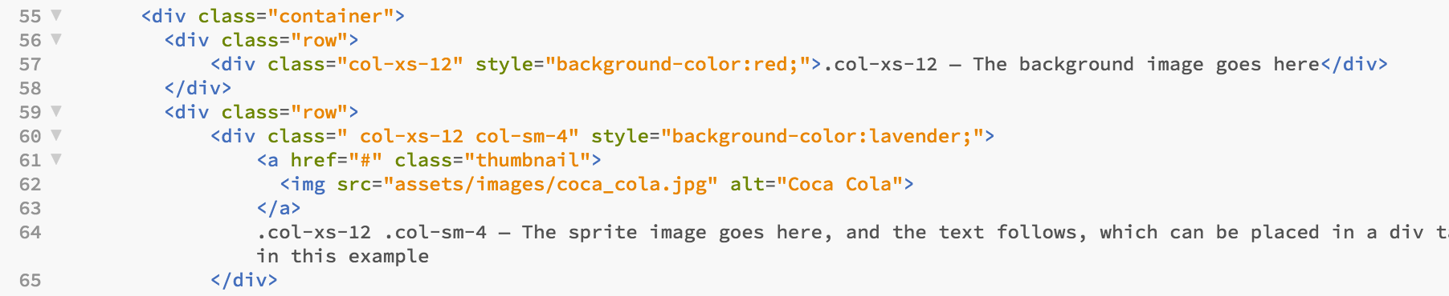

Figure 45: Lay out the images Bootstrap 3 in 2017

We can see from this code that we have applied Bootstrap’s thumbnail class. This class was used to extend Bootstrap’s grid system to display grids of images, videos, text and more. This was quite nice, if you have a look at the Dreamweaver CS6 version (year 2016) you will see this is a bit of an efficiency gain! You could still use the Bootstrap 3 library.

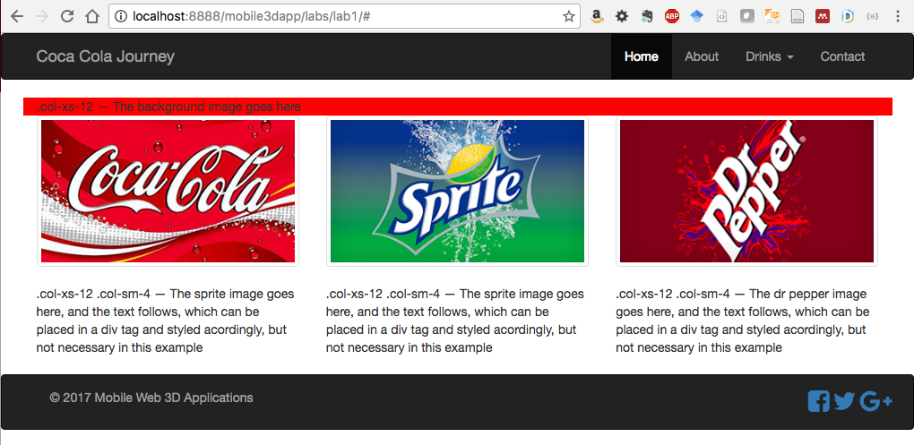

Figure 46: The 3 drinks images inserted using Bootstrap 3 thumbnail class

Bootstrap 4.3 [Images](https://getbootstrap.com/docs/4.3/content/images/) also has a new img-thumbnail class that we can use, basically they changed the .thumbnail class to the .img-thumbnail class, as far as I can see. However, this year we will use the Bootstrap 4.3 [Cards](https://getbootstrap.com/docs/4.3/components/card/) to embed our images.

## Appendix J — CSS media queries

What is a CSS media query? Put simply, the @media rule or query is used to define different style rules for different sized screen devices. It allows us to change the style, or brand even, across your mobile, tablet, desktop, etc.

Given this, we often need to be able to organise media screen breaks for each of the common screen devices. If you are using Bootstrap, it is common to default to the Bootstrap screen breaks and ensure we include at least those for mobile, tablet and desktop screen sizes, but your specific design might require a finer division, e.g. everyone’s 3D App will be different!

If you are building a mobile first responsive design, this effectively means you should design the layout and design for the mobile first, then apply different CSS rules through @media screen breaks, and different layouts for the larger screen sizes. You, of course, could just as easily design for non-mobile first, both will work! Indeed, if you look at the custom.css file for the Bootstrap 2016 Lab 1 result you will see organized the CSS for non-mobile first.

At this point it is worth noting that some will argue that designing for screen breakpoint sizes is not that good an idea, and we should design for [content specific breakpoints](http://dmolsen.com/2013/03/05/media-query-less-design-content-based-breakpoints-tweakpoints/) and use [content first design](https://responsivedesign.is/design/content-first-design). Then again, others, on the same site mind, argue that we should design [mobile first but not for specific devices](https://responsivedesign.is/strategy/page-layout/defining-breakpoints), and when you scale up and the design starts to look crap, then insert media query breakpoints. Well, we have to start somewhere, so we leave it to you to research this issue further; in the meantime, here is a list of [common media query breakpoints](https://responsivedesign.is/develop/browser-feature-support/media-queries-for-common-device-breakpoints), again from the same site — this list of comprehensive breakpoints allow for both device landscape and portrait mode starting with mobile first. You can copy these into your custom.css file if you like.

You can also use [Sass](https://sass-lang.com/) ([Syntactically Awesome style sheet](https://www.w3schools.com/sass/)) to style your 3D App. Sass can be used to reduce repetition of CSS rules, and thus save time, but your 3D App will not be that complex. So, for now we will stick to CSS.

## Appendix K — Working from home

You may have noticed in this tutorial that I have been previewing our Lab 1 results as we create them in a Chrome browser served from my localhost environment (I happen to use MAMP on an iMac at home and in my office, so it is very convenient to keep my Local files on Dropbox).

However, once your site is developed and tested, the next step is to load it up to a remote web server for publishing online. If you are developing offsite, perhaps on a laptop at home, then you will need to use a SFTP client such as [Filezilla](https://filezilla-project.org/), [Cyberduck](https://cyberduck.en.softonic.com/mac) or [WinSCP](http://www.sussex.ac.uk/its/services/software/owncomputer/winscp) to connect to your remote web server using the SFTP (secure file transfer protocol). You can also mount your Unix N: drive on your local machine using Webdrive. Using an actual SFTP client is described in another tutorial, which can be found in the Canvas resource section for this laboratory, or ITS help also offer a guide for [Students accessing N Drive files from home](http://www.sussex.ac.uk/its/help/guide?id=49).

## Appendix L — Using Git and GitHub for to manage your code

Git is a distributed control system for tracking changes in your code files and projects. Actually, it doesn’t need to be just code, you could also use GitHub to store and track changes in word documents, markdown, anything really[4].

Some guidelines for installing and using Git and GitHub with Visual Studio Code:

**Step 1**: First you will need to install Git — so read [about Git](https://git-scm.com/about) to get a good idea of how it works.

* You can [download Git](https://git-scm.com/downloads) and install using the downloaded installer, or you can follow the install instructions on the Github site — [Installing Git – the easy way](https://gist.github.com/derhuerst/1b15ff4652a867391f03#file-mac-md).
* Alternatively, if you are looking to set up a reasonable development environment on your own laptop, PC or Mac, then I recommend a Madness Labs tutorial, which covers [Environment Setup](https://www.youtube.com/watch?v=O5-zaf2Kcus) including Node.js, Git and Visual Studio Code. Node.js is a useful JavaScript web server based on the Chrome V8 engine, which allows you to run JavaScript on the server side. However, we won’t be using this in any of our Informatics based labs because I can’t predict how node.js will work yet in the labs. But, you might find it useful on your own machine. Further, both Git and Node.js are command line tools, you can use Visual Studio Code with Git integrated to sync all your code to GitHub (if you choose).
* When you have installed Git, you can continue to use it locally, **but we highly recommend that you create a remote repository**. A remote repository is most useful when you are working in a team. However, if, like me, you are in the habit of using multiple computers, i.e. my office machine, a laptop and my home machine, then I can easily sync up working from multiple locations. In actual fact, I use Dropbox as my local repository, which is even better as my local Git repository is also on Dropbox by default. I tend to edit in the office, home, laptop, but only push my files to GitHub from the office. There is a certain double safety element built-in here: 1) my files are effectively backed up on Dropbox (and if you can’t trust Dropbox to look after your files — costs me £79/year for 1 TByte — who can you trust). You have other options too, I think the University gives you access to box.com, you might use Google Drive, etc.), and 2) using GitHub also adds a remote repository (backup). Imagine the scenario, whereby you do all your development on your laptop, you even use Git locally on your Laptop, and that laptop goes everywhere with you — then you leave it on the bus! It has happened.

**Step 2**: Setup a GitHub account — but, read the [GitHub Guides](https://guides.github.com/activities/hello-world/) first to get a good idea of how it works.

* As a remote repository, I am suggesting that you use GitHub, a web based [Git version control repository hosting service called GitHub](https://en.wikipedia.org/wiki/GitHub), there are others. If you do use GitHub, you will need to create an account, etc. GitHub offers private and free accounts. GitHub offers everything Git does, and a few more features, etc. Further, there are several GUIs that you can use on top of Git or GitHub, but I like to use either the GitHub interface as it is and Visual Studio Code. Once you have set up your project in GitHub, you can simply connect Visual Studio Code and it runs very smoothly.
* Note, when sign up for a [GitHub.com account](https://github.com/) you will be asked to choose either an ‘unlimited public repository plan’ (recommended, unless you are developing something you want to keep private) or choose an ‘unlimited private repositories’ for $7 a month. You can skip the next step, and then you land on the ‘Learn Git and GitHub without any code!’ page. Click on the ‘Read the Guide button, to get going on the [GitHub Guides](https://guides.github.com/activities/hello-world/) already mentioned above.
* You will need to connect your local Git repository to your GitHub repository in some way, and I recommend you do this through Visual Studio Code. There are many online guides on how to do this, but again, Madness Labs illustrates tow tutorials o how to do this: 1) [Using Git with Visual Studio Code and GitHub](https://www.youtube.com/watch?v=9cMWR-EGFuY&t=40s) tutorial shows you how to first create a GitHub project, pull it down to Visual Studio Code, and then you start developing your code locally and push back up, or 2) do the opposite, i.e. connect your [Visual Studio Code to GitHub Remote Manually](https://www.youtube.com/watch?v=I7WfxhF2wEg&t=75s). This, is done by creating your local Git as above, then creating a remote GitHub and linking them.
* Also, the official docs for [Using Version Control in Visual Studio Code](https://code.visualstudio.com/docs/editor/versioncontrol) are worth a quick skim, and this YouTube tutorial: [Visual Studio Code #4 Git Integration](https://www.youtube.com/watch?v=6n1G45kpU2o) is quite useful for using Git locally.
* Finally, here is an online tutorial tool: [Got 15 minutes and want to learn Git?](https://try.github.io/levels/1/challenges/1)

Finally, you may not be aware that GitHub has an **education site**: <https://education.github.com/>, where you can download the **GitHub Student Developer Pack**: <https://education.github.com/pack>, amongst other useful things, including access to **GitHub Campus Experts**: <https://githubcampus.expert/experts>, Sussex has one, look up who it is.

That’s it, as I say this is an optional exercise, but might be useful to manage your code for this 3D App module between developing in the lab and at home. You can just as easily manage your code manually.

1. https://getbootstrap.com/docs/4.2/components/card/
2. https://getbootstrap.com/docs/4.2/utilities/spacing/
3. https://github.com/FezVrasta/popper.js#installation
4. https://en.wikipedia.org/wiki/Git